Sequence 5: image formed by a converging lens

** Fiches de synthèse mobilisées** (collection en français) :

* Fiche n°4 : lentilles convergentes et modèle optique de l’œil
* Fiche n°5 : la relation de conjugaison des lentilles

** Sommaire des activités ETLV** :

ACTIVITY 1: determining the focal length of a converging lens

ACTIVITY 2: comparing focal length measurements

ACTIVITY 1: determining the focal length of a converging lens

An emmetropic eye (without any visual defect) sees a far optical object without any effort, it does not accommodate. The observation without accommodation through an optical system can be done only if the image is formed at infinity. Afocal systems, such as optical telescopes, allow this effortless observation.

A method called “**autocollimation**” (studied further in sequence 5, activity 2) uses one simple mirror in order to find focal length of a converging lens.

**DOCUMENT 1: focal points of a converging lens**

A thin converging lens has two focal points, located on the optical axis, a distance f from the center of the lens on either side. This distance f is the focal length of the lens.

① ②

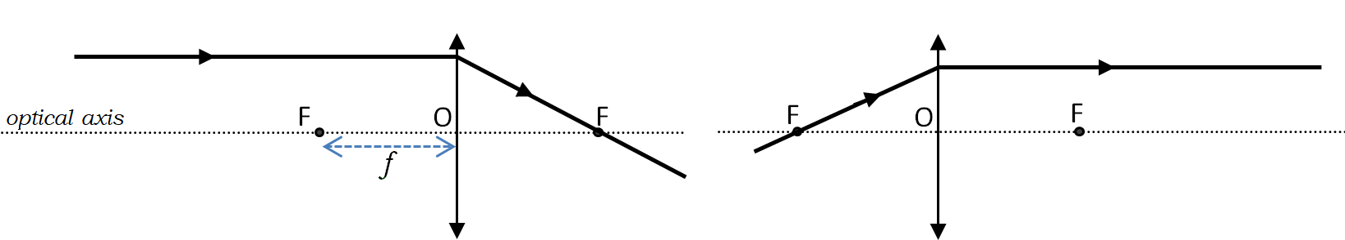

① A ray entering a converging lens parallel to the optical axis passes through the focal point on the other side of the lens.

② A ray that passes through the focal point exits the converging lens parallel to the optical axis.

**DOCUMENT 2: plane mirrors**

A plane mirror is a mirror with a flat reflective surface. For [light](https://en.wikipedia.org/wiki/Light) [rays](https://en.wikipedia.org/wiki/Ray_(optics)) striking a plane mirror, the angle of [reflection](https://en.wikipedia.org/wiki/Reflection_(physics)) r equals the angle of incidence i.

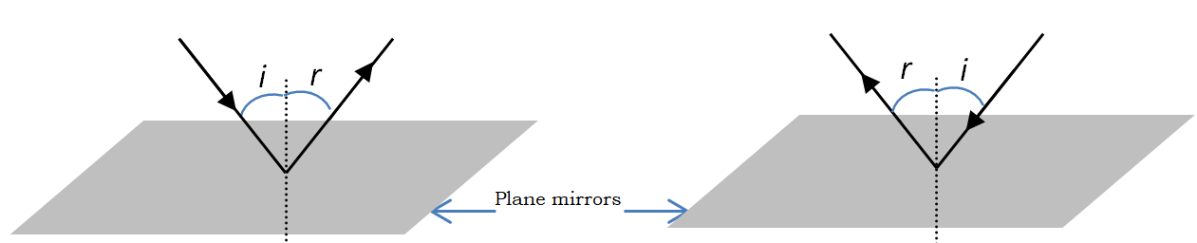

**DOCUMENT 3: the refracting telescope**

The refracting telescope is an afocal system made of two converging lenses (L1 and L2); it allows far object observation without any accommodation. The light rays coming from infinity are represented by a parallel light beam:

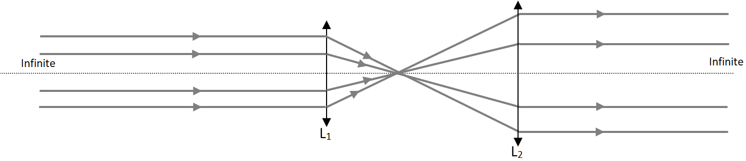

**DOCUMENT 4: available laboratory equipment**

* An optical bench with a source light and an optical object (a *p* letter);
* A plane mirror;
* A 5-diopter converging lens.

### Acquiring vocabulary:

|  |  |
| --- | --- |
| **English** | **French** |
|  | Autocollimation |
| Afocal system |  |
| Light ray |  |
| Light beam |  |
| Plane mirror |  |
| Optical bench |  |
|  | Infini |
|  | Lentille convergente |
| Focal length |  |
| Optical axis |  |
| Retina |  |

### Questions

1. **UNDERSTANDING DOCUMENTS**
   1. The focal points on document 3 are not represented. Draw them on each lens L1 and L2.
   2. Draw a parallel light beam entering lens L2 on document 3.
2. **ANALYZING**
   1. Imagine a light source S, placed on the focal point of a converging lens (on the left-hand side of the lens). The light beam that exits the lens, encounters a plane mirror placed perpendicular to the optical axis. Map all the light rays, from the light source to the mirror and after their reflections.
   2. What can we say about the positions of the light source and its image?
3. **EXPERIMENTING** With the available laboratory equipment on your table, carry out the previous experiment.
4. **COMMUNICATING** One of your mates is missing today. You have to explain to him/her the autocollimation method in order to identify the focal point of a converging lens.

### Application

We can observe on the following picture an operator positioning a plane mirror in front of a converging lens. The light source is a *P* object.

* **What is the focal length of this converging lens?**

The optical power is defined as the inverse of the focal length. It is expressed in diopters (δ).

* 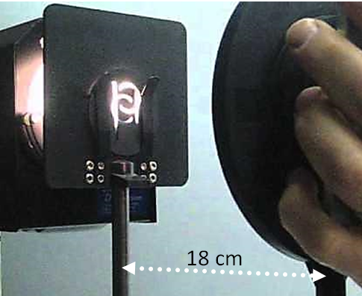**What is the optical power of this converging lens?**

Connaissances et capacités à maîtriser

Ce qu’il faut savoir :

### Le vocabulaire à savoir définir et utiliser à bon escient :

* Emmetropic
* To accommodate
* Autocollimation
* A light beam
* Infinite
* A converging lens
* The focal points
* The optical axis
* An afocal system

### Les grandeurs physiques à savoir définir et exprimer avec la bonne unité :

* The focal length f’
* The optical power

### Les relations à connaître et à savoir exploiter :

$optical power \left(diopter\right)= \frac{1}{focal length (meter)}$

Ce qu’il faut savoir faire :

|  |  |  |
| --- | --- | --- |
| **Compétences** | **Capacités à maîtriser** | **Où dans cette séquence ?** |
| **RCO** | Focal length | Document 1 |
| Optical power | Application |
| **APP** | Utiliser du vocabulaire spécifique | Question 4 |
| Lire et comprendre des documents scientifiques | Question 1 |
| **ANA** | Mettre en lien des documents pour émettre des hypothèses en réponse à une question scientifique | Question 2 |
| **REA** | Mettre en œuvre un protocole | Question 3 |
| **COM** | S’exprimer à l’oral en utilisant le vocabulaire adapté | Question 4 |