Sequence 4: optical model of the eye

** Fiches de synthèse mobilisées** (collection en français) :

* Fiche n°4 : lentilles convergentes et modèle optique de l’œil
* Fiche n°5 : la relation de conjugaison des lentilles

** Sommaire des activités ETLV** :

ACTIVITY 1: accommodation of the emmetropic eye

ACTIVITY 2: correcting myopia with eyeglasses

ACTIVITY 3: correcting presbyopia with eyeglasses

ACTIVITY 1: accommodation of the emmetropic eye

Nearly 70 percent of the French population is affected by defects of vision (visual defects). These defects are myopia, hypermetropia and presbyopia. An optical equipment allows to recover a good eyesight, whatever the visual defect is.

**DOCUMENT 1: a model of the emmetropic eye**

An emmetropic eye, **without any visual defect**, can be modeled with an optical bench: a 10 diopter (10 δ) converging lens behind a diaphragm and a screen 110 mm far from the lens. You have another converging lens the optical power of which is 5 diopters (5 δ, the less convex lens) and an optical object (light source). For an unaccommodated emmetropic eye, the **far point** is at infinity, but for the sake of practicality, infinity is considered to be **6 m** because the accommodation change from **6 m to infinity** is negligible. For an emmetropic eye, the **near point is located 25 cm** from the eye.

**DOCUMENT 2: near point and far point**

The **near point** is the minimum distance from the eye, for which a clear image of an object can be seen.

The **far point** is the maximum distance from the eye, for which a clear image of an object can be seen.

Accommodation is the process by which the [eye](https://en.wikipedia.org/wiki/Eye" \o "Eye) changes [optical power](https://en.wikipedia.org/wiki/Optical_power) to maintain a clear image as the distance from the optical object varies.

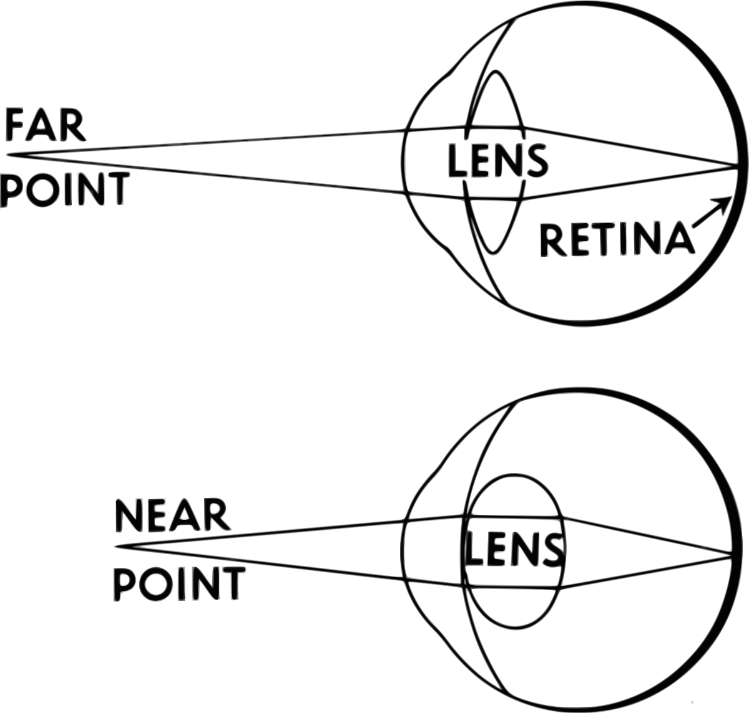

**Source: Wikimedia commons**

**DOCUMENT 3: the human lens**

The human lens is a transparent, biconvex structure in the eye that helps to refract light to be focused on the retina. The changing shape changes the optical power of the eye. The optical power increases with the convex shape of the lens and allows seeing clear images of near objects.

### Acquiring vocabulary:

|  |  |
| --- | --- |
| **English** | **French** |
| visual defects |  |
| Myopia, near-sightedness |  |
| Hypermetropia, far-sightedness |  |
| presbyopia |  |
| Emmetropic eye |  |
| infinity |  |
| Converging lens |  |
| Far point |  |
| Near point |  |
| retina |  |
| Optical power |  |

### Experimenting:

* **Propose and carry out an experimental protocol to model the accommodation of a human eye observing a 1000 mm distant object. Repeat once again for a 170 mm distant object.**
* **COMMUNICATING**

**Write a report to present your work and to make everyone understand your choices.**

ACTIVITY 2: correcting myopia with eyeglasses

**DOCUMENT 4: myopia (nearsighted eye)**

Myopia (near-sightedness) is a visual defect where light focuses in front of, instead of on, the [retina](https://en.wikipedia.org/wiki/Retina), especially when the eye is too long. **For a myopic eye, far point** is located at a finite distance. This causes distant objects to be blurry while close objects appear normal. Meaning that the eye cannot see optical objects situated at too far a distance from the eye. **For a myopic eye, near point** is closer to the eye than for an emmetropic eye (a normal eye).

**DOCUMENT 5: correcting myopia**

To correct myopia, there are different solutions such as wearing contact lenses, eyeglasses or doing laser eye surgery. Corrective lenses for myopia are divergent lenses (with **negative powers**) as it is required to move the far point out to the distance.

### Acquiring vocabulary:

|  |  |
| --- | --- |
| **English** | **French** |
| Shape |  |
| Blurry |  |
| eyeglasses |  |

### Experimenting:

* **Propose and carry out an experimental protocol in order to determine the near point of a model of a nearsighted eye.**

***Note that a nearsighted eye can be modeled by a converging lens of +10 diopters and a screen located 125mm behind this lens.***

* **With the available laboratory equipment on your bench, modify the previous set up in order to see an optical object situated at infinity when the eye is wearing eyeglasses.**
* **COMMUNICATING**

**Write a report to present your work and to make everyone understand your choices.**

ACTIVITY 3: correcting hypermetropia with eyeglasses

**DOCUMENT 6: hypermetropia (farsighted eye)**

Hypermetropia (far-sightedness) is a visual defect where light focuses behind, instead of on, the retina, especially when the eye is too short or not convergent enough. Near point is at finite distance and the eye can’t see clearly farther.

**DOCUMENT 7: correcting hypermetropia**

To correct hypermetropia, there are different solutions such as wearing contact lenses, eyeglasses or doing laser eye surgery. They move the clear image closer to reach the retina.

### Experimenting:

* **Propose and carry out an experimental model of a farsighted eye observing a 1000 mm far object (the image is therefore seen blurry).**

***Note that a farsighted eye can be modeled by a converging lens of +10 diopters and a screen located 90 mm behind this lens.***

* **With the available laboratory equipment on your bench, modify the previous apparatus to see clearly the previous optical object when the eye is wearing eyeglasses.**
* **COMMUNICATING**

**Write a report to present your work and to make everyone understand your choices.**

Connaissances et capacités à maîtriser

Ce qu’il faut savoir :

### Le vocabulaire à savoir définir et utiliser à bon escient :

* Emmetropic
* To accommodate
* A lens
* The retina
* Myopia
* Hypermetropia

### Les grandeurs physiques à savoir définir et exprimer avec la bonne unité :

* The optical power (diopter)

Ce qu’il faut savoir faire :

|  |  |  |
| --- | --- | --- |
| **Compétences** | **Capacités à maîtriser** | **Où dans cette séquence ?** |
| **RCO** | Optical power | Activités 1 à 3 |
| **APP** | Utiliser du vocabulaire spécifique | Activités 1 à 3 |
| Lire et comprendre des documents scientifiques | Activités 1 à 3 |
| **ANA** | Mettre en lien des documents pour émettre des hypothèses en réponse à une question scientifique | Activités 1 à 3 |
| **REA** | Mettre en œuvre un protocole | Activités 1 à 3 |
| **COM** | S’exprimer à l’oral en utilisant le vocabulaire adapté | Activités 1 à 3 |