Sequence n° 15: storing, reading information
- Data on DVD’s
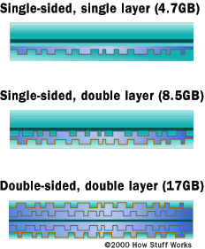Document 1: DVD formats
DVDs are of the same diameter and thickness as CDs, and they are made using some of the same materials and manufacturing methods. Like a CD, the data on a DVD is encoded in the form of small pits and bumps in the track of the disc.
A DVD is composed of several layers of plastic, totaling about 1.2 millimeters thick. Each layer is created by injection molding polycarbonate plastic. This process forms a disc that has microscopic bumps arranged as a single, continuous and extremely long spiral track of data.
Once the clear pieces of polycarbonate are formed, a thin reflective layer is sputtered onto the disc, covering the bumps. Aluminum is used behind the inner layers, but a semi-reflective gold layer is used for the outer layers, allowing the laser to focus through the outer and onto the inner layers. After all of the layers are made, each one is coated with lacquer.
Source: wikimedia commons

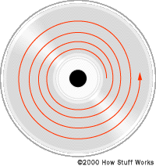Document 2: DVD tracks
What the image cannot impress upon you is how incredibly tiny the data track is -- just 740 nanometers separate one track from the next (a nanometer is a billionth of a meter). And the elongated bumps that make up the track are each 320 nanometers wide, a minimum of 400 nanometers long and 120 nanometers high. The figure below illustrates looking through the polycarbonate layer at the bumps.

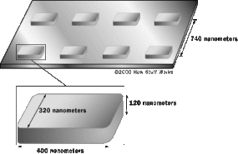The microscopic dimensions of the bumps make the spiral track on a DVD extremely long. If you could lift the data track off a single layer of a DVD, and stretch it out into a straight line, it would be almost 7.5 miles long! That means that a double-sided, double-layer DVD would have 30 miles (48 km) of data!
To read bumps this small you need an incredibly precise disc-reading mechanism.

Source: wikipedia

Acquiring vocabulary
English | French
thickness
data
encoded
pits
bumps
long spiral track
To sputter

Presenting conclusions
Read documents 1 and 2 and explain how information is stored on a DVD.

Activity summary
What you must remember:
- data
- spiral track

Skills linked to the curriculum:

Compétences | Capacités à maitriser
APP | Extraire les informations jugées pertinentes concernant :  − les dimensions caractéristiques du CD (distances, capacité́ de stockage)  − le principe de la lecture du disque optique  Expliquer le principe de codage des données sur un support optique numérique.
COM | Utiliser un vocabulaire scientifique adapté  Présenter des résultats

