Sequence n° 14: transmitting information
- Fiber-optic cables
Document 1: Transmitting information through fiber-optic cables
In fiber optics, information is sent in the form of a beam of light down a glass and plastic pipe. It was originally developed for endocopes in the 1950s to help doctors see inside the human body without having to cut it open first. In the 1960s, engineers found a way of using the same technology to transmit telephone calls at the speed of light (normally that's 186,000 miles or 300,000 km per second in a vacuum, but slows to about two thirds this speed in a fiber-optic cable).
Source: wikipedia
Document 2: How fiber-optics works
Total internal reflection keeps light rays bouncing down the inside of a fiber-optic cable.
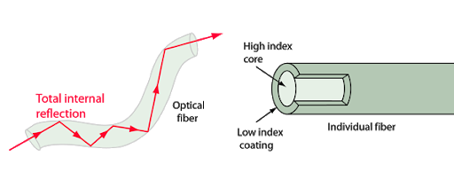
Light travels down a fiber-optic cable by bouncing repeatedly off the walls. Each tiny photon (particle of light) bounces down the pipe like a bobsleigh going down an ice run. Now you might expect a beam of light, traveling in a clear glass pipe, simply to leak out of the edges. But if light hits glass at a really shallow angle (less than 42 degrees), it reflects back in again—as though the glass were really a mirror. This phenomenon is called total internal reflection. It's one of the things that keeps light inside the pipe.
The other thing that keeps light in the pipe is the structure of the cable, which is made up of two separate parts. The main part of the cable—in the middle—is called the core and that's the bit the light travels through. Wrapped around the outside of the core is another layer of glass called the cladding. The cladding's job is to keep the light signals inside the core. It can do this because it is made of a different type of glass to the core.
Source: wikipedia

Understanding fiber-optics
Work out an estimation of the speed of light in a fiber-optic cable using document 1.
____________________________________________________________________________________
What is the role of reflection in fiber optics?
____________________________________________________________________________________

Activity summary
What you must remember:
- optical fiber
- reflection

Skills linked to the curriculum:
Compétences | Capacités à maitriser
- APP | – Comprendre et mobiliser des connaissances en lien avec le problème posé  – Extraire une information jugée pertinente  – Identifier et utiliser la complémentarité́ d’informations
- ANA | Expliquer le principe du guidage par une fibre optique.  Relier les informations présentées dans les documents concernant la fibre optique aux connaissances sur la transmission d’informations.
- COM | Formuler et argumenter des réponses structurées  Formuler et présenter une conclusion

