Sequence n° 10: the eye and the magnifying glass

1. A homemade magnifying glass!

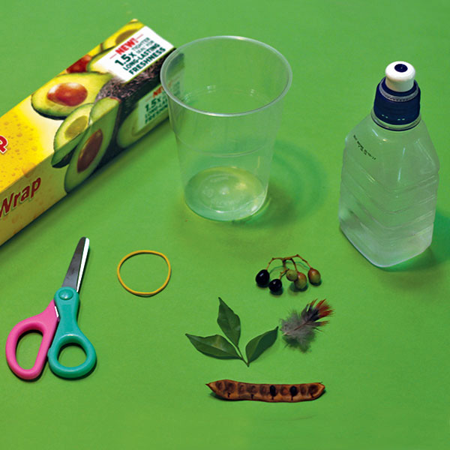**Document 1: Making a magnifying glass with water**

**Materials needed:**

- A plastic cup

- Cling wrap

- Rubber band

- Scissors

- Water

- And some interesting specimens to look at

### Acquiring vocabulary

|  |  |
| --- | --- |
| **English** | **French** |
| magnifying glass |  |
| sharp focus |  |
| lens |  |

### Hands on practice

**Using the materials given in document 1, prepare your own magnifying glass.**

Activity summary

What you must remember:

**- magnifying glass**

**- microscope**

Skills linked to the curriculum**:**

|  |  |
| --- | --- |
| **Compétences** | **Capacités à maitriser** |
| * ANA | Définir le grossissement commercial d’une loupe, établir et exploiter son expression en fonction de la distance focale. |
| * REA | **Mettre en œuvre un protocole très simple pour réaliser** une maquette de loupe |
| * COM | Utiliser du vocabulaire spécifique |