Sequence n° 6: polarization
- Which sunglasses for a summer by the lake?
Document 1: polarization by reflection
Unpolarized light can undergo polarization by reflection off of nonmetallic surfaces. The extent to which polarization occurs is dependent upon the angle at which the light approaches the surface and upon the material that the surface is made of. Metallic surfaces reflect light with a variety of vibrational directions; such reflected light is unpolarized. However, nonmetallic surfaces such as asphalt roadways, snowfields and water reflect light such that there is a large concentration of vibrations in a plane parallel to the reflecting surface. A person viewing objects by means of light reflected off of nonmetallic surfaces will often perceive a glare if the extent of polarization is large. Fishermen are familiar with this glare since it prevents them from seeing fish that lie below the water. Light reflected off a lake is partially polarized in a direction parallel to the water's surface. Fishermen know that the use of glare-reducing sunglasses with the proper polarization axis allows for the blocking of this partially polarized light. By blocking the plane-polarized light, the glare is reduced and the fisherman can more easily see fish located under the water.
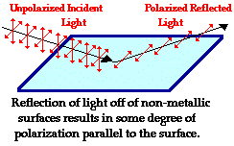
Source: wikimedia commons

Document 2: polaroid filter
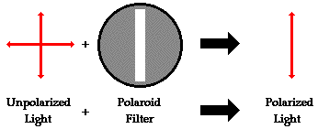
Source: wikimedia commons

Problem: choosing your summer glasses
Identify the pair of glasses that is capable of eliminating the glare resulting from sunlight reflecting off the calm waters of a lake? (The polarization axes are shown by the straight lines.)
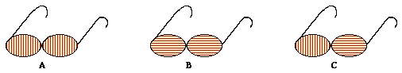
Source: wikimedia commons

Activity summary
What you must remember:
- polarization
- reflection

Skills linked to the curriculum:

Compétences | Capacités à maitriser
APP | Extraire les informations jugées pertinentes concernant la direction de polarisation d'une onde électromagnétique  Prévoir l’effet d’un polariseur sur une lumière naturelle et sur une onde polarisée rectilignement.  Citer des exemples d’ondes partiellement polarisées et non polarisées.
COM | Utiliser un vocabulaire scientifique adapté  Présenter des résultats

