Sequence n° 4: sound waves
- Sound waves

Part 1 : Sound properties

DOCUMENT 1: Sound Waves

What type of wave is sound? How does it travel from one medium to another medium? Is it a mechanical wave or longitudinal wave or pressure wave?

Mechanical Waves
One important characteristic of sound waves is that they are mechanical waves. This means that they travel through a medium. Sound waves can travel through all sorts of mediums. Normally, we hear sound waves that have travelled through air, but sound can also travel through water, wood, the Earth, and many other substances. Sound cannot travel through a vacuum like outer space, however.

The source of sound waves is something vibrating. This vibration causes a disturbance in the molecules around the source. The energy of the wave is transferred from molecule to molecule within the medium.

Longitudinal Waves
Another characteristic of sound waves is that they are longitudinal waves. This means that the disturbance of the wave travels in the same direction as the wave. As the molecules vibrate and transfer energy to each other they cause a wave that moves in the direction of the vibration.

What is the wavelength of a sound wave?
We studied how the wavelength of a transverse wave is measured from crest to crest or trough to trough. This is fairly easy to see when looking at a graph. However, sound waves are different as they are longitudinal. To determine the wavelength of a sound wave you measure from compression to compression or rarefaction to rarefaction.
Pressure Waves
Sound waves can also be thought of as pressure waves. This is because the compressions and rarefactions that move through sound waves have different pressures. The compressions are areas of high pressure while the rarefactions are areas of low pressure.

DOCUMENT 2: Sound properties

Vidéo : https://www.khanacademy.org/science/ap-physics-1/ap-mechanical-waves-and-sound/introduction-to-sound-waves-ap/v/sound-properties-amplitude-period-frequency-wavelength

DOCUMENT 3: Range of frequencies of some common animals compared to humans

- Multiple Choice Quiz: Choose the right answer

- Because a sound wave must travel through a medium, it is called a ________ wave.
- Mechanical
- Electrical
- Light
- Electromagnetic
- Induction

- What is the source of a sound wave?
- Electricity
- Vibration
- Light waves
- Conduction
- Tiny nuclear explosions

- What does it mean that a sound wave is a longitudinal wave?
- The disturbance moves perpendicular to the wave
- The period of the wave is very long
- The disturbance moves in the same direction as the wave
- The wave has a very low frequency
- The waves last for a long time

- What do we call the region of a sound wave where the molecules are bunched closer together?
- Interference
- Refraction
- Polarization
- Rarefaction
- Compression

- What do we call the areas of low pressure of a sound wave?
- Interference
- Refraction
- Polarization
- Rarefaction
- Compression
- Representing waves – interpreting graphs

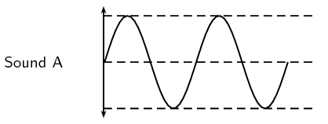

Period T

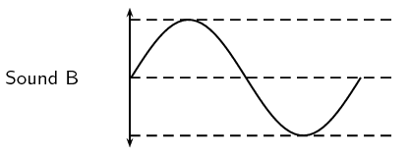

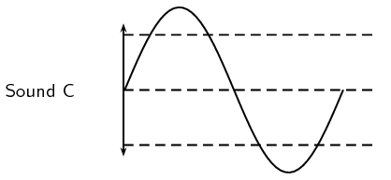
What quantity is shown on the x-axis? Give the name and symbol.
What quantity is shown on the y-axis? Give the name and symbol.

Complete these sentences with the words amplitude or period:

Sound wave B has a greater ……………………………. than sound wave A.
Sound wave C has a greater ……………………………. than sound wave A.

From the graphs, you can see that the height of the waves A and C changes. What does this tell you about the loudness of these sounds?

You can also see that the wave B is becoming more widely-spaced than the wave A. The period is changing. Is it increasing or decreasing? How is the frequency of the wave changing? What would you notice if you heard this sound?

Complete the table document 3 with the data given in the video.

Using the information given in Document 3, calculate the lower and upper wavelengths that each species can hear. Assume the speed of sound in air is 344 m.s⁻¹.

- Work in groups :

Create a poster in order to present the sound waves, using diagrams and images.
Present your work and your ideas orally to the class.

Part 2: Range of hearing experiment

In this experiment, the teacher can find the highest note which any student in the class can hear. This is called the upper limit of hearing. Look at the picture of the experiment:

Source : wikimedia commons

- Describing an experiment:

Write down a series of instructions to carry out this experiment in order to demonstrate the upper limit of hearing of each student in the class.

You will write instructions in the imperative, include just one idea in each instruction and give your instructions in a sensible order.

Activity summary
What you must remember:
- vocabulary used to describe a sound wave
- the properties and characteristics of sound waves

Skills linked to the curriculum:

Compétences | Capacités à maitriser
- ANA | - Analyser la propagation d’une perturbation dans un milieu  - Modéliser une onde acoustique par la propagation d’une vibration mécanique et d’une surpression.  - Comparer la célérité du son dans différents milieux, citer des ordres de grandeur des valeurs de célérité dans un gaz, un liquide ou un solide.  - Savoir expliciter les différentes grandeurs physiques intervenant dans le modèle d’une onde progressive sinusoïdale
- COM | - Restituer ses connaissances à l’oral

