Sequence n° 2: wave propagation
- Tidal bore

Document 1: Tidal bores

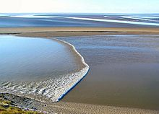

A tidal bore is a tidal phenomenon in which the leading edge of the incoming tide forms a wave (or waves) of water that travels up a river or narrow bay against the direction of the river or bay's current.

Bores occur in relatively few locations worldwide, usually in areas with a large tidal range (typically more than 6 meters (20 ft) between high and low tide) and where incoming tides are funneled into a shallow, narrowing river or lake via a broad bay. The funnel-like shape not only increases the tidal range, but it can also decrease the duration of the flood tide, down to a point where the flood appears as a sudden increase in the water level. A tidal bore takes place during the flood tide and never during the ebb tide.

Source: wikipedia

Document 2: Arnside bore

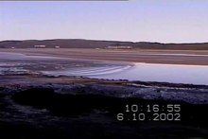 Watch : https://en.wikipedia.org/wiki/Tidal_bore

Source: wikipedia

Document 3: Problem

A detector detects a tidal bore at distance x₀ = 400m inside the river inlet.

The wave has a speed of c = 20 km.h⁻¹. A surfer is waiting for the wave at x_{surf} = 1,9km on the river.

How long will he have to wait for the bore?

Understanding tidal bores: vocabulary

Read documents 1 and watch document 2. The table below contains definitions. Insert the correct word next to each definition using Document 1.

Word | Definition
 | Contre le courant
 | Vague
 | Phénomène de marée
 | Marée
 | Marée descendante
 | Marée montante
 | Peu profond

Understanding tidal bores: problem

Give a numerical answer to the surfer’s problem in Document 3

______________________________________________________________________________________

Activity summary
What you must remember:
- propagation
- celerity

Skills linked to the curriculum:

Compétences | Capacités à maitriser
- APP | Faire le lien entre la situation réelle et le modèle proposé.
- ANA | Caractériser et identifier des ondes transversales et des ondes longitudinales.  Représenter et exploiter les graphes des évolutions temporelle et spatiale du phénomène observé.
- COM | Formuler et argumenter des réponses structurées  Formuler et présenter une conclusion

