Chapter 8: spectroscopic analysis
- Spectrophotometry: using a calibration curve
This activity was started in 1ere STL.
DOCUMENT 1: BSA protein
Source: Wikipedia
Bovine serum albumin (also known as BSA or "Fraction V") is a serum albumin protein derived from cows. It is often used as a protein concentration standard in lab experiments.
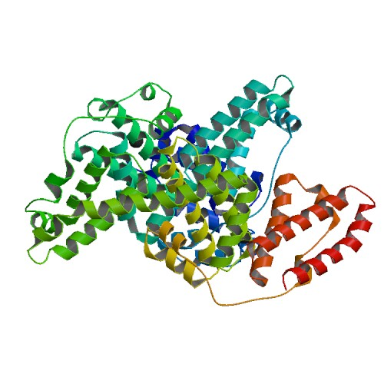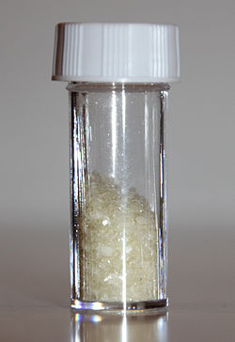
www.wikimediacommons.org
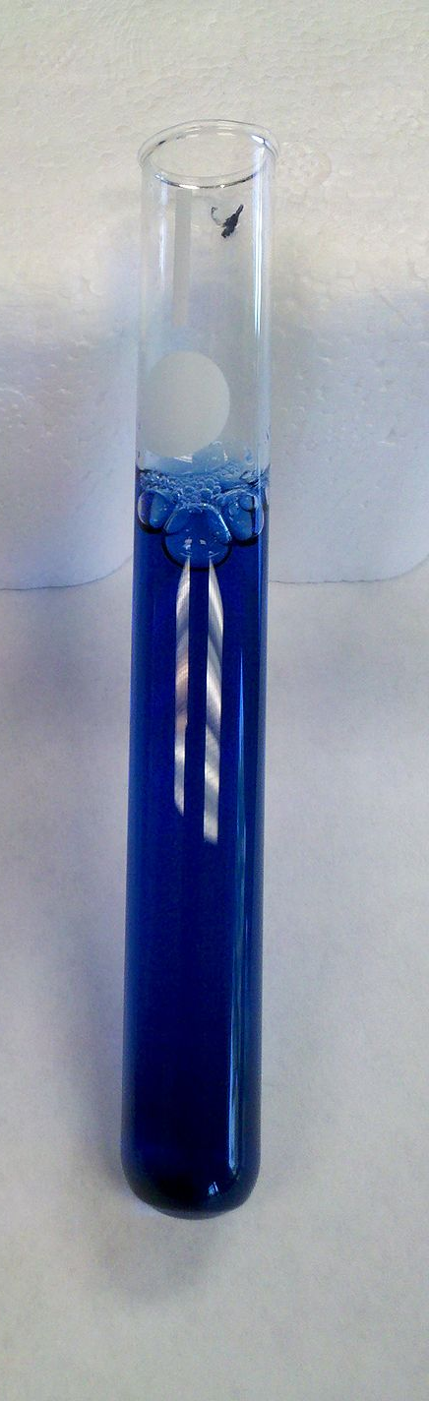
DOCUMENT 2: Spectrophotometry measurements with proteins using Brilliant Blue dye (Bradford method)
Source: Wikipedia

The dye (Bradford reagent) associated with BSA protein has an absorption spectrum maximum at 595 nm. The increase of absorbance at 595 nm is proportional to the amount of bound dye, and thus to the concentration of protein present in the sample.
The procedure for Bradford protein assay is very easy and simple to follow. It is done in one step where the Bradford reagent is added to a test tube along with the sample. After mixing well, the mixture almost immediately changes to a blue color and the absorbance can be read at 595 nm using a spectrophotometer.
DOCUMENT 3: Procedure for standard assay
Source: Wikipedia

Procedure (Standard Assay, 20-150 µg protein; 200-1500 µg/mL)

- Prepare a series of protein standards diluted with 0.15 M NaCl to final concentrations of 0 (blank = NaCl only), 250, 500, 750 and 1500 µg/mL. Also prepare serial dilutions of the unknown sample to be measured.
- Add 100 µL of each of the above to a separate test tube
- Add 5.0 mL of dye to each tube and mix by vortex, or inversion.
- Adjust the spectrophotometer to a wavelength of 595 nm, and blank using the tube which contains no protein.
- Wait 5 minutes and read each of the standards at 595 nm wavelength.
- Plot the absorbance of the standards vs. concentration.
DOCUMENT 4: BSA protein calibration curve
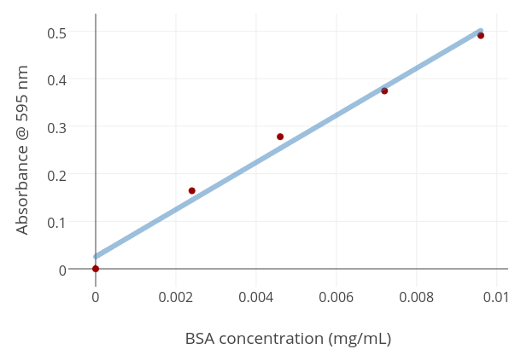

Figure: Calibration curve - generated from BSA samples measured at 595nm
Source: Wikipedia

Presentation (5min)
Using the calibration curve, explain how you would determine the concentration of an unknown solution of BSA protein:
_________________________________________________________________________________________________
_________________________________________________________________________________________________

Activity summary
What you must remember:
- how to calculate a concentration using a calibration curves

Skills linked to the curriculum:

Compétences | Capacités à maitriser
- COM  - APP | Concevoir et mettre en œuvre un protocole pour déterminer la concentration d’une espèce à l’aide d’une droite d’étalonnage établie par spectrophotométrie.

