Chapter 7: separation and extraction
- Recrystallization – choosing the right solvent
DOCUMENT 1: Recrystallization video
MIT Open Course Ware :
https://ocw.mit.edu/resources/res-5-0001-digital-lab-techniques-manual-spring-2007/videos/

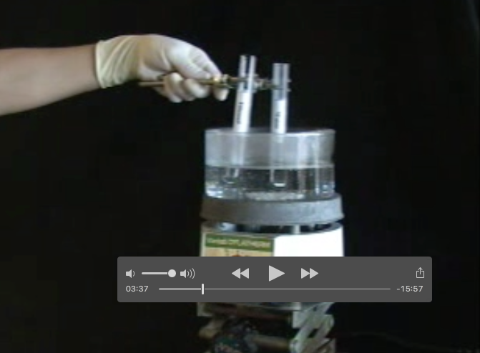

This video has already been studied in 1ere STL SPCL. We will only focus on the choice of solvent.
DOCUMENT 1: Choosing the right solvent

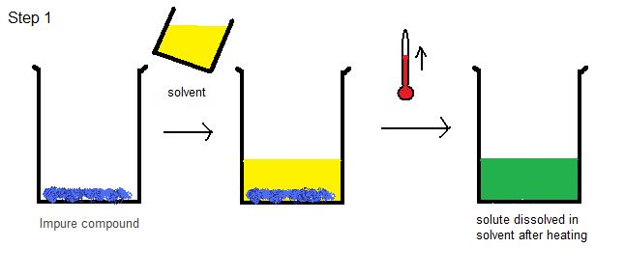

What is the ideal solvent in the video? Why? Explain.
_________________________________________________________________

Activity summary
What you must remember:
- vocabulary associated with choosing a solvent during recrystallisation
- how to choose a solvent

Skills linked to the curriculum:

Compétences | Capacités à maitriser
- ANA | Choisir le solvant d’extraction ou de recristallisation à partir de données tabulées.
- COM | Effectuer et présenter un choix de solvant

