Chapter 6: organic synthesis

1. Benzaldehyde synthesis from cinnamon

**DOCUMENT 1: Cinnamon**

Cinnamon is a spice obtained from the inner bark of several tree species from the genus Cinnamomum. Cinnamon is used mainly as an aromatic condiment and flavoring additive in a wide variety of cuisines, sweet and savoury dishes, breakfast cereals, snackfoods, and traditional foods. The aroma and flavor of cinnamon derive from its essential oil and principal component, cinnamaldehyde, as well as numerous other constituents, including eugenol.

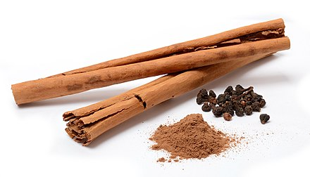

**Source: https://en.wikipedia.org/wiki/Cinnamon**

**DOCUMENT 2: Chemicals**

**a)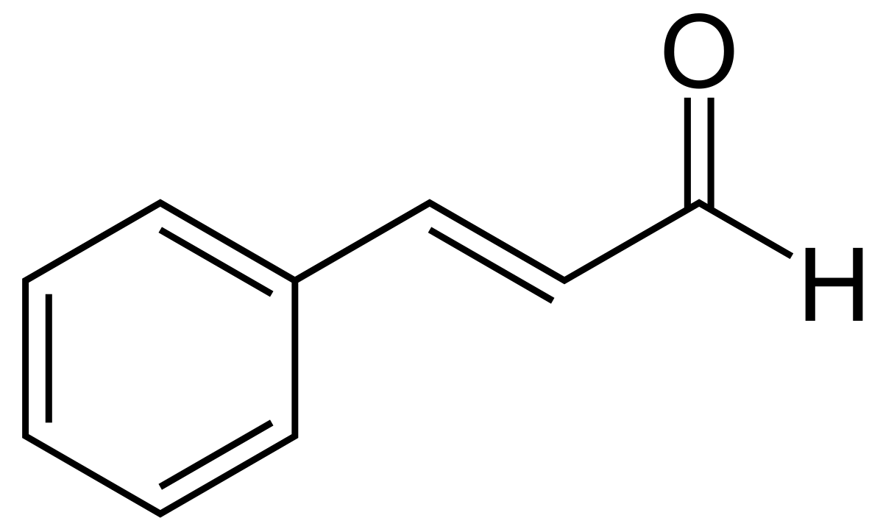b)**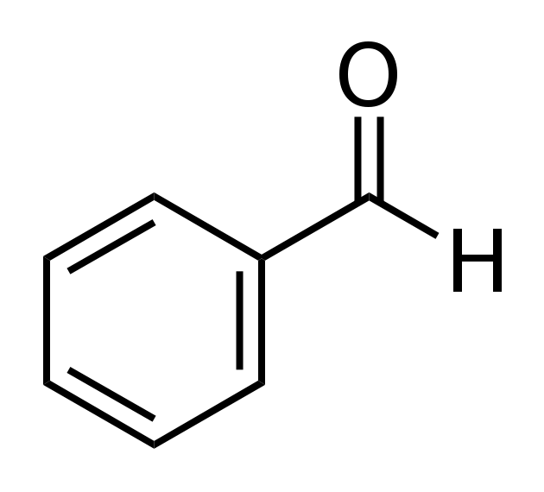

**c)** 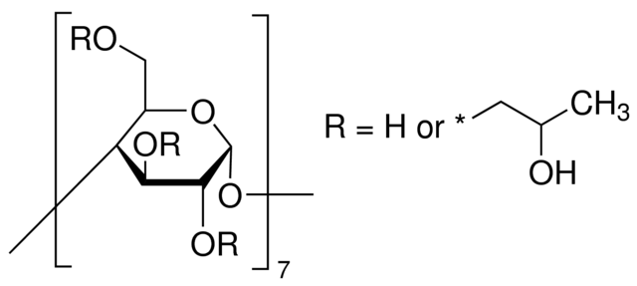

**Source: https://en.wikipedia.org/**

**DOCUMENT 3: Benzaldehyde synthesis**

Natural benzaldehyde, the second largest perfume in the world, has captivated many researchers’ interest both in organic synthesis and industry, as benzaldehyde plays important roles in food, beverages, cosmetics, and pharmaceutical industries etc. Moreover, compared to chemically synthetic benzaldehyde, natural benzaldehyde is more popular and represents a strong market advantage. Generally natural benzaldehyde is derived from alkaline hydrolysis of Laetrile catalyzed by enzyme, however, the process needs to thoroughly dispose of the toxic hydrocyanic acid, which results in high cost for production. […]

In this paper, a practical challenge is to explore a water-soluble and robust catalyst, that is, able to increase reaction selectivity for the hydrolysis of cinnamaldehyde to benzaldehyde under mild reaction conditions efficiently. For this purpose, 2-hydroxypropyl- $β$-CD (2-HP- $β$-CD) was used to catalyze the hydrolysis of cinnamaldehyde (**Scheme 1**). 2-HP- $β$-CD is a highly water-soluble catalyst.



**Source: Green synthesis of natural benzaldehyde from cinnamon oil catalyzed by hydroxypropyl- $β$-cyclodextrin.**

Hongyan Chen, Hongbing Ji, Xiantai Zhou, Lefu Wang, 12 June 2010.

### Acquiring vocabulary:

|  |  |
| --- | --- |
| **English** | **French** |
| a spice |  |
| cinnamaldehyde |  |
| water-soluble |  |
| catalyst |  |
| a practical challenge |  |
| selectivity |  |
| mild conditions |  |

### Identifying reactant, product and catalyst

Using the documents, identify all three chemicals given in **document 2**.

Which chemical is extracted from cinnamon?

What is (are) the role(s) of 2-HP- $β$-CD in this synthesis?

Activity summary

What you must remember:

catalysis

Skills linked to the curriculum:

|  |  |
| --- | --- |
| **Compétences** | **Capacités à maitriser** |
| * ANA | Identifier les fonctions ester, anhydride d’acide, amide et chlorure d’acyle dans une formule chimique.  Associer un nom à une molécule organique simple.  Identifier les facteurs permettant d’accélérer une réaction : changement de température, de concentration, utilisation d’un catalyseur.  Comparer des protocoles de synthèse et choisir le plus performant en termes de rendement, de coût et de respect de l’environnement, en s’appuyant sur les principes de la chimie verte. |
| * COM | Formuler et argumenter des réponses structurées  Formuler et présenter une conclusion |