Chapter 3: conductivity and conductometry

1. Conductometric titration of a cough syrup

### ****Introduction****

### ****Objectives:** The present study developed and validated a conductometric method for determination of Diphenhydramine HCl (DPH) in its pure form and in a syrup formulation using silver nitrate ($AgNO_{3}$).**

### ****Methods:** Conductometric titration method was achieved by using $AgNO_{3}$. The method is built on the reaction of chloride ions coming from the DPH with $Ag^{+}$ yielding silver chloride precipitate. Conductance of the solution is measured as a function of the volume of titrant. The proposed method is linear over the range of 1-10mg.**

### Source: Conductometric determination of the antihistaminic diphenhydramine hydrochloride using silver nitrate as a titrant analytical chemistry department, Zagazig University, Egypt

**DOCUMENT 1: Diphynelhydramine HCl (DPH)**

DPH (Fig. 1) is a first-generation anti-histaminic possessing anti-allergic, antitussive and sedative properties that is mainly used to treat allergies. It is found in various pharmaceutical preparations.

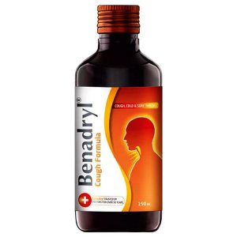

**Source: Conductometric determination of the antihistaminic diphenhydramine hydrochloride using silver nitrate as a titrant analytical chemistry department, Zagazig University, Egypt**

**DOCUMENT 2: Cough syrup titration**

A dose of cough syrup is titrated using silver nitrate titrant:



Molar concentration of $(Ag^{+},NO_{3}^{-})$**solution: $C={5.10}^{-3}M$**

**Source: Conductometric determination of the antihistaminic diphenhydramine hydrochloride using silver nitrate as a titrant analytical chemistry department, Zagazig University, Egypt**

### Acquiring vocabulary

|  |  |
| --- | --- |
| **English** | **French** |
| conductimetric titration |  |
| to treat allergies |  |
| cough syrup |  |
| titrant |  |

### Problem solving

What is the mass of DPH in the dose of cough syrup titrated in **document 2**?

Activity summary

What you must remember:

- Conductivité

- Conductivité ionique molaire

Skills linked to the curriculum**:**

|  |  |
| --- | --- |
| **Compétences** | **Capacités à maitriser** |
| * ANA | Interpréter ou prévoir l’allure d’une courbe de titrage conductimétrique à partir de données, sans tenir compte de l’effet de la dilution. |
| * REA | Réaliser un protocole de titrage mettant en jeu une réaction suivie par conductimétrie. |
| * COM | Formuler et argumenter des réponses structurées  Formuler et présenter une conclusion |