Chapter 3: conductivity and conductometry
- Salinity of sea water
Objective: using a calibration curve in order to determine an unknown concentration

Introduction

The first step in using conductivity to determine salinity is to quantify the relationship between conductivity and salinity. In other words, we want to know exactly how conductivity changes when salinity changes.

The best way to do this is to use samples with known salinities and measure their conductivity with a conductimeter (or salinometer). Making conductivity measurements on samples with a known salinity, oceanographers can determine the salinity on unknown samples. Oceanographers typically use commercially available standardized seawater (with a precisely measured salinity) to calibrate their salinometers.

Table 1 below illustrates typical conductivity of various samples with a known salinity at 20 °C and atmospheric pressure.

Source: http://hrsbstaff.ednet.ns.ca/vturner/handouts%20Oceans%2011/Salinity%20and%20Conductivity.pdf

Table 1: Conductivity measurements of standard solutions
Source: http://hrsbstaff.ednet.ns.ca/vturner/handouts%20Oceans%2011/Salinity%20and%20Conductivity.pdf
Salinity (g salt/kg water) | Conductivity (mS/cm)
25.6 | 40.0
27.4 | 42.5
28.4 | 44
29.9 | 46
31.7 | 48.5
33.2 | 50.5
34.3 | 52
35.8 | 54
38 | 57
39.5 | 59

Table 2: Conductivity measurements of unknown solutions
Source: http://hrsbstaff.ednet.ns.ca/vturner/handouts%20Oceans%2011/Salinity%20and%20Conductivity.pdf
Sample | Conductivity (mS/cm)
1 | 41
2 | 45.5
3 | 47
4 | 50

DOCUMENT 1: Ocean salinity in g salt/kg water (or part per thousand)

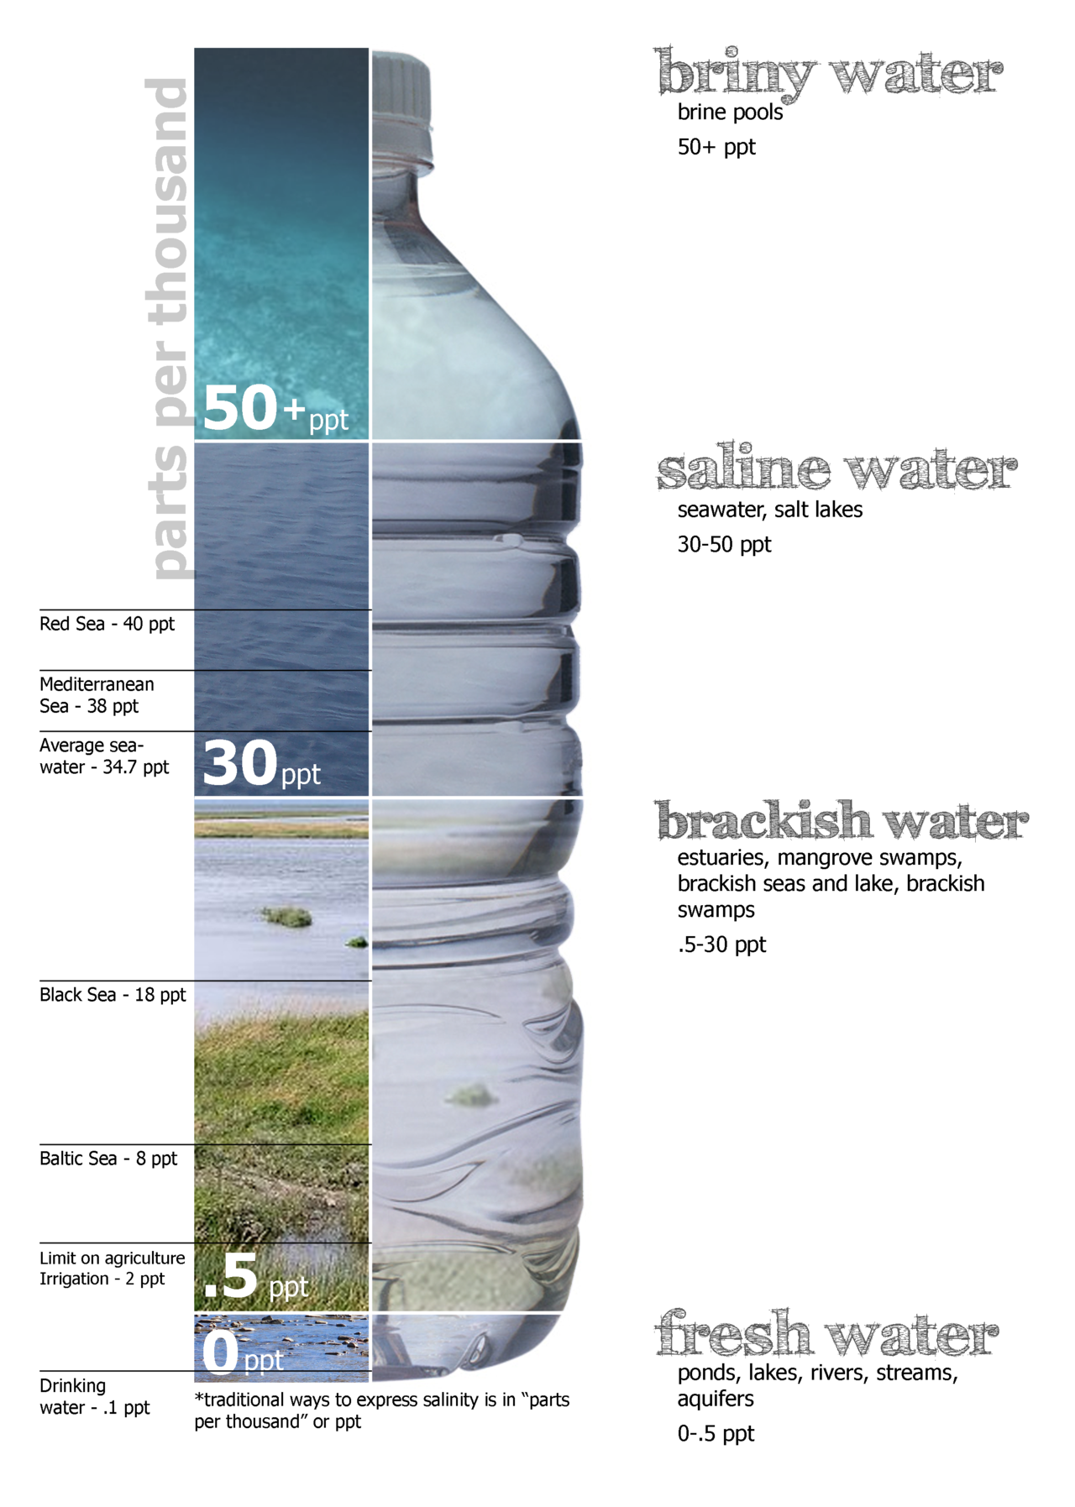

Source: https://en.wikipedia.org/wiki/Salinity#/media/File:Water_salinity_diagram.png

Using a calibration curve
Using all documents, determine the salinity of the four samples in Table 2. Determine which category of water they belong to: fresh water (drinkable), brackish water, saline water, briny water?

Activity summary
What you must remember:
- conductivity
- standard solution
- calibration curve

Skills linked to the curriculum:

Compétences | Capacités à maitriser
- ANA | Interpréter ou prévoir l’allure d’une courbe de titrage conductimétrique à partir de données, sans tenir compte de l’effet de la dilution.
- REA | Réaliser un protocole de titrage mettant en jeu une réaction suivie par conductimétrie.
- COM | Formuler et argumenter des réponses structurées  Formuler et présenter une conclusion

