Chapter 3: conductivity and conductometry
- Choosing the best electrolyte: water electrolysis experiment

Problem
During the electrolysis of water, which electrolyte conducts electricity the best?
DOCUMENT 1: Materials

- Distilled water
- Tap water
- 2 silver-colored thumb tacks
- 9V battery
- Small, clear plastic container (a plastic to-go sauce container from a restaurant would work great)
- 2 test tubes
- Stopwatch
- Baking soda
- Table salt
- Lemon
- Dishwashing detergent

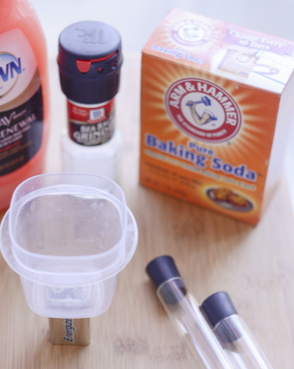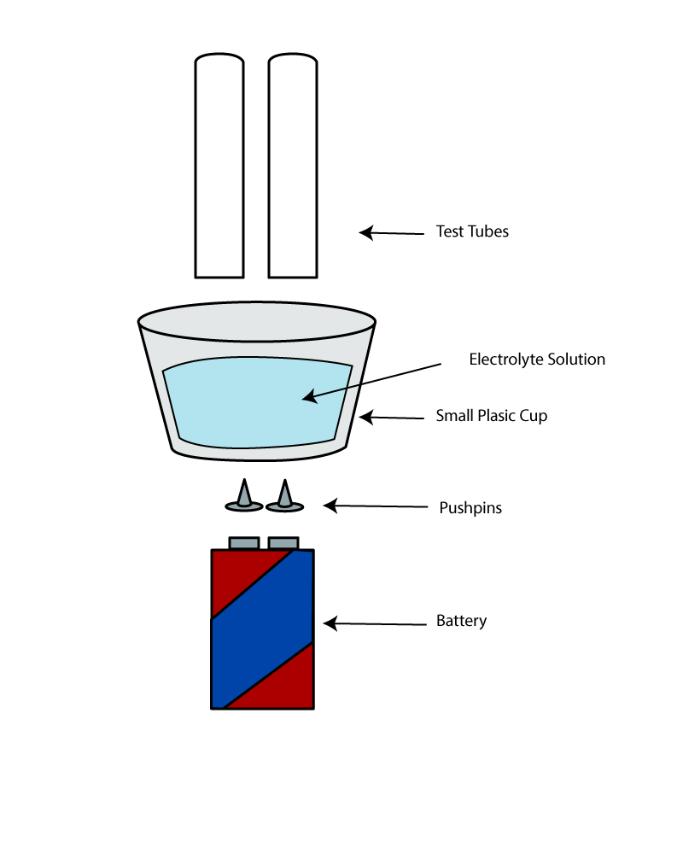
Source: https://www.education.com/science-fair/article/water-electrolysis/

DOCUMENT 2: Procedure

- Insert the thumb tacks into the bottom of the plastic container so that the points push up into the container. Space them so that they’re the same distance apart as the two terminals of the 9V battery. Be careful not to prick yourself!
- Place the plastic container with the thumb tacks over the terminals of the battery. If the cup is too large to balance on the battery, find something to stack it on: between two books, a stack of post-its, etc.
- Slowly fill the container with distilled water. If the tacks move, go ahead and use this opportunity to fix them before you proceed.
- Add a pinch of baking soda.
- Hold two test tubes above each push pin to collect the gas being formed. Record your observations.
- Discard the solution, and repeat the procedure with a different combination:
Distilled water and lemon juice
Distilled water and table salt
Distilled water and dish detergent
Distilled water (no additive)
Tap water

Source: https://www.education.com/science-fair/article/water-electrolysis/

Acquiring vocabulary:
English | French
baking soda
dish detergent
table salt
tap water

Understanding the process (skip ahead to chapter 4 and chapter 5 on electrolysis!)
Carry out the experiment.
Present your results orally and try to answer the problem: during the electrolysis of water, which electrolyte conducts electricity the best? Make sure to explain why.

Activity summary
What you must remember:
- Conductivité
- Conductivité ionique molaire

Skills linked to the curriculum:

Compétences | Capacités à maitriser
- APP | Connaitre la notion de conductivité
- REA | Exploiter et interpréter les mesures expérimentales
- COM | Formuler et argumenter des réponses structurées  Formuler et présenter une conclusion

