Chapter 1: solubility
- Problem solving at the hospital

Problem
Theo, a nurse student needs to prepare a saline solution fit for nasal or eye rinsing. His solution should be equivalent to the over the counter solution proposed in document 1. The room temperature is 15°C. Here is the protocol he decides to follow:

1. Weigh out 9.0 g of salt.
2. Place the salt in a 1L volumetric flask
3. Add a small volume of distilled water to dissolve the salt.
4. Fill the flask to the 1L line, invert and swirl several times.

Will he manage to prepare the solution without any difficulties even though the temperature is a bit cold today?

Molar mass of NaCl = 58.4 g/mol
DOCUMENT 1: Saline solution at 0,9% weight per volume

-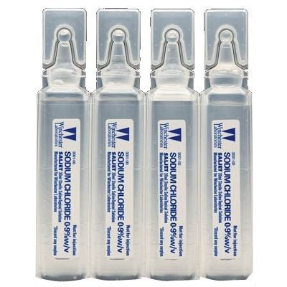
Source: https://www.dowa.co/content/images/thumbs/0000586_pic-sterile-saline-solution.jpeg
DOCUMENT 2: Solubility product
https://en.wikipedia.org/wiki/Solubility_equilibrium#/media/File:SolubilityVsTemperature.png
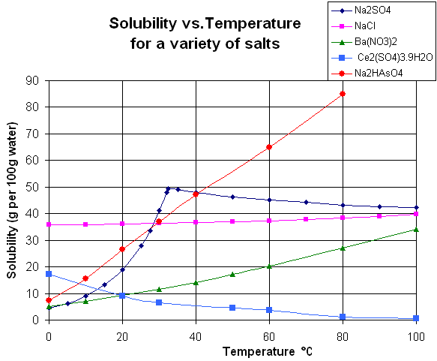

https://en.wikipedia.org/wiki/Solubility_equilibrium#/media/File:SolubilityVsTemperature.png

Source: https://www.dowa.co/content/images/thumbs/0000586_pic-sterile-saline-solution.jpeg

Activity summary
What you must remember:
- molarity
- volumetric flask
- percentage by weight (w/v)

Compétences | Capacités à maitriser
- APP | Exploiter des documents scientifiques
- ANA | Utiliser le produit de solubilité.
- REA | Prévoir l’influence de la température sur la solubilité d’une espèce chimique en exploitant des données.
- COM | Formuler et argumenter des réponses structurées  Formuler et présenter une conclusion

