CH10: titrations
- Titration

Part 1: Using a video
Watch video “Volumetric Techniques” from the MIT online learning course. (Start at 7min30s end at 10min)
Volumetric techniques https://ocw.mit.edu/resources/res-5-0001-digital-lab-techniques-manual-spring-2007/videos/
Which main key words did you hear in the video?
__________________________________________________________________________________
What is the objective in this lab experiment?
__________________________________________________________________________________

Part 2: Vocabulary help, filling in the blanks
English | French
to get rid of air bubbles
to drain a burette to the 0 mark
to read at eye level
to disassemble
to overshoot an endpoint
to undershoot an endpoint
to near = to approach the endpoint
the endpoint
a rough titration
to add titrant in small increments
to add titrant one drop at a time
to disappear

Part 3 : Using a document
1) 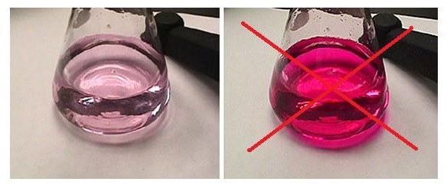
2)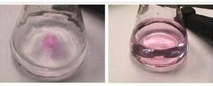
What happened in document 1)? Explain in a sentence using the given vocabulary.
__________________________________________________________________________________
3) 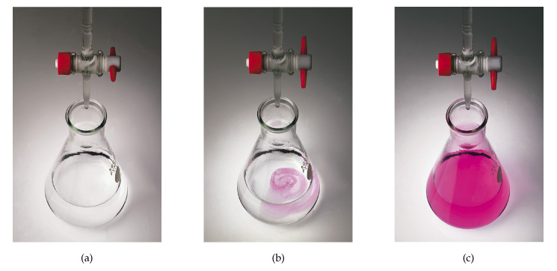
Explain the three steps in the document above:
a) _________________________________________________________________________________
b) _________________________________________________________________________________
c) _________________________________________________________________________________

Activity summary
What you must remember:
- vocabulary associated with titration
- how to check for the endpoint
- how to carry out a titration

Skills linked to the curriculum:

Compétences | Capacités à maitriser
- APP | - Connaître le vocabulaire lié au titrage
- COM | - Savoir expliquer le repérage d’une équivalence

