CH9: titrations using calibration
- Spectrophotometry : using a calibration curve
DOCUMENT 1: BSA protein
Source: Wikipedia
Bovine serum albumin (also known as BSA or "Fraction V") is a serum albumin protein derived from cows. It is often used as a protein concentration standard in lab experiments.
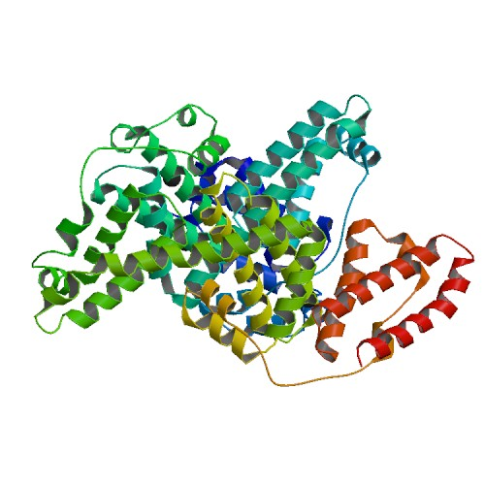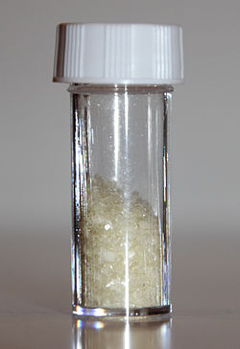
www.wikimediacommons.org
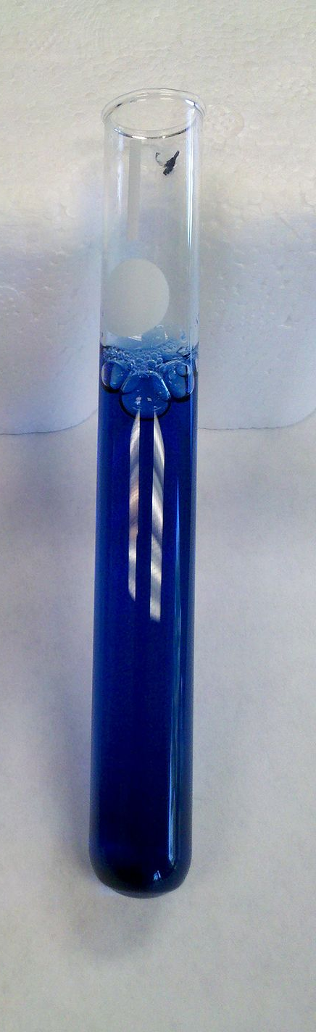
DOCUMENT 2: Spectrophotometry measurements with proteins using Brilliant Blue dye (Bradford method)
Source: Wikipedia

The dye (Bradford reagent) associated with BSA portein has an absorption spectrum maximum at 595 nm. The increase of absorbance at 595 nm is proportional to the amount of bound dye, and thus to the concentration of protein present in the sample.
The procedure for Bradford protein assay is very easy and simple to follow. It is done in one step where the Bradford reagent is added to a test tube along with the sample. After mixing well, the mixture almost immediately changes to a blue color and the absorbance can be read at 595 nm using a spectrophotometer.

DOCUMENT 3: Procedure for standard assay
Source: Wikipedia

Procedure (Standard Assay, 20-150 µg protein; 200-1500 µg/mL)

- Prepare a series of protein standards diluted with 0.15 M NaCl to final concentrations of 0 (blank = NaCl only), 250, 500, 750 and 1500 µg/mL. Also prepare serial dilutions of the unknown sample to be measured.
- Add 100 µL of each of the above to a separate test tube
- Add 5.0 mL of dye to each tube and mix by vortex, or inversion.
- Adjust the spectrophotometer to a wavelength of 595 nm, and blank using the tube which contains no protein.
- Wait 5 minutes and read each of the standards and each of the samples at 595 nm wavelength.
- Plot the absorbance of the standards vs. concentration.
DOCUMENT 4: BSA protein calibration curve
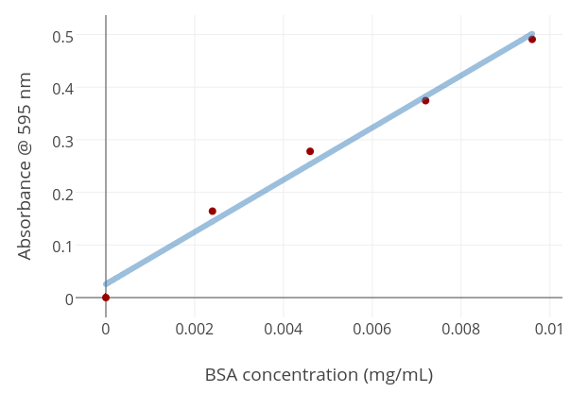

Figure: Calibration curve - generated from BSA samples measured at 595nm
Source: Wikipedia

Vocabulary
Using the previous documents, fill in the blanks:
French | English
 | lab experiments
 | wavelength
une mesure
un essai
un échantillon
un colorant
 | (protein) bound dye
 | the process
absorbance
une courbe d’étalonnage
 | reagent

Presentation
Prepare a short 2min presentation :
Using the knowledge acquired in chemistry class and document 3, recap the procedure carried out during spectrophotometry measurements?
_________________________________________________________________________________________________
_________________________________________________________________________________________________
_________________________________________________________________________________________________
_________________________________________________________________________________________________

Questions
At which wavelength were measurements carried out on BVA protein? Explain.
_________________________________________________________________________________________________
_________________________________________________________________________________________________
_________________________________________________________________________________________________

According to document 2, how was this value chosen?
_________________________________________________________________________________________________
_________________________________________________________________________________________________
_________________________________________________________________________________________________
_________________________________________________________________________________________________
_________________________________________________________________________________________________

An unknown sample has an absorbance of A = 0,3, work out the BSA concentration in the sample
_________________________________________________________________________________________________
_________________________________________________________________________________________________

Activity summary
What you must remember:
- vocabulary associated with spectrophotometry mesasurements
- how to explain spectrophotometry measurements
- how to calculate a concentration using a calibration curves

Skills linked to the curriculum:

Compétences | Capacités à maitriser
- COM  - APP | - Savoir expliquer un protocole
- APP  - ANA | - Savoir exploiter une courbe d’étalonnage

