CH7: Physico-chemical analyses
- Is your tap water drinkable ?
DOCUMENT 1 : Collecting a sample
www.wikimediacommons.org
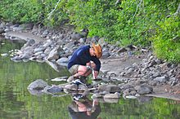
DOCUMENT 2: Examples of water analysis equipment
www.wikimediacommons.org
1) 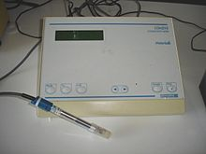 2) 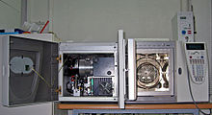
1) A conductimeter used to measure ion concentration
2) A gas chromatograph, mass spectrometer used to measure pesticides
DOCUMENT 3: Water analyses
www.wikimediacommons.org
- Color of water
- pH
- Taste and odor (geosmin, 2-Methylisoborneol (MIB), etc.)
- Dissolved metals and salts (sodium, chloride, potassium, calcium, manganese, magnesium)
- Microorganisms such as fecal coliform bacteria (Escherichia coli), Cryptosporidium, and Giardia lamblia
- Dissolved metals and metalloids (lead, mercury, arsenic, etc.)
- Dissolved organics: colored dissolved organic matter (CDOM), dissolved organic carbon (DOC)

DOCUMENT 4: US Environmental Protection Agency water standards
http://extension.psu.edu/natural-resources/water/drinking-water/water-testing/testing/how-to-interpret-a-water-analysis-report

Contaminant | Acceptable Limit | Sources/Uses | Potential Health Effects at  High Concentrations
Benzene | .005 ppm | gasoline additive; usually from accidental oil spills, industrial uses, or landfills | Immune system depression; acute exposure affects central nervous system causing dizziness, headaches; long term exposure increases cancer risks
Lead ion $Fe^{2+}$ | 0.3 mg.L⁻¹ | used in batteries; lead gasolines; may be leached from brass faucets, lead pipes, and lead soldered joints | nervous disorders and mental impairment, especially in fetuses and infants; kidney damage; blood disorders and hypertension; low birth weights
Nitrate ion ${NO_{3}}^{-}$ | 45 mg.L⁻¹ | soil by-product of agricultural fertilization; human and animal  waste leaching to groundwater | methemoglobinemaia (blue baby disease) in infants (birth to 6 months); low health threat to children and adults
Total Coliform | <1 colony /100 mL | bacterial or viral contamination from human sewage or animal manure | diarrhea, constant high level exposure can lead to cholera and hepatitis
Common nuisance contaminants and their effects.
Contaminant | Acceptable Limit | Sources/Uses
Copper ion ${Cu}^{2+}$ | 1.3 mg.L⁻¹ | blue-green stains on plumbing fixtures; bitter metallic taste
Manganese ion ${Mn}^{2+}$ | 0.05 mg.L⁻¹ | black stains on fixtures and laundry; bitter taste
Chloride ion $Cl^{-}$ | 250 mg.L⁻¹ | salty or brackish taste; corrosive; blackens and pits  stainless steel
Sulfate ion ${SO_{4} }^{2-}$ | 250 mg.L⁻¹ | greasy feel, laxative effect

DOCUMENT 5 : Louisiana water analysis
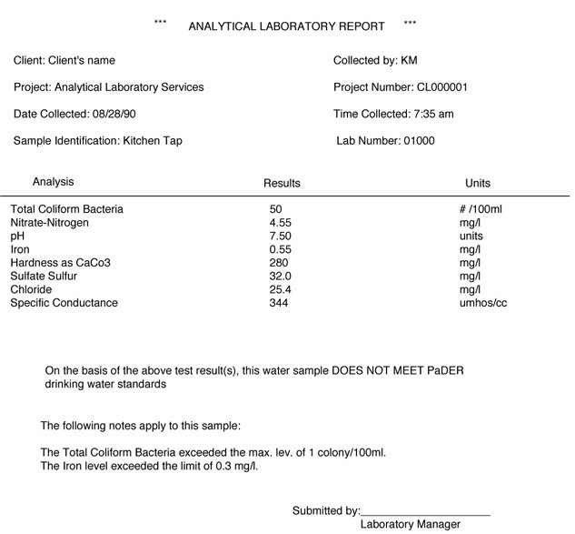

DOCUMENT 6 : Fluvanna water analysis
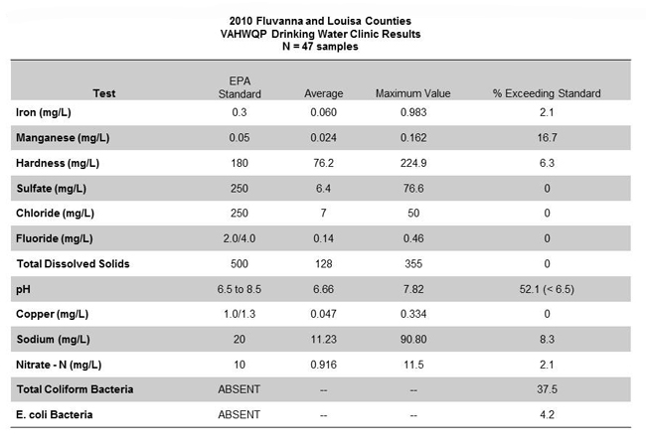

Acquiring vocabulary: filling in the blanks
Using the documents, find the meaning of the following words :
English | French
a water sample
an analysis, two analyses
a conductimeter
exposure (to a pollutant)
an oil spill
a landfill
sewage
leakage
groundwater
kitchen tap

Learning about water analyses : documents 1 to 3

According to documents 1 to 3, which common analyses are carried out on as sample?

Give examples of pieces of equipment that can be used?

Analysing a laboratory report : documents 4 to 6
According to documents 4 to 6, is the Louisiana tap water drinkable?

Similarly, in your opinion is the Fluvanna tap water drinkable?

Presenting
Present your results in a 1min presentation. You can choose to search for your local tap water analysis.

Activity summary
What you must remember :
- vocabulary associated with water analysis

Skills linked to the curriculum :

Compétences | Capacités à maitriser
- APP | - Connaître le vocabulaire lié aux analyses d’une eau de ville
- APP  - ANA  - COM | - Citer des analyses physico-chimiques mises en œuvre dans le cadre d’études environnementales.
- APP  - ANA  - COM | - Savoir analyser, interpréter des résultats de dosage afin de déterminer la potabilité d’une eau de ville.
- COM | - Savoir présenter les résultats d’une analyse et des conclusions.

