Sequence n° 6: Synthesis
- Aspirin synthesis

Part 1: Medical applications
In 1897, Felix Hoffman, a German chemist, first synthesized a stable form of acetylsalicylic acid for medical use, better known as aspirin.
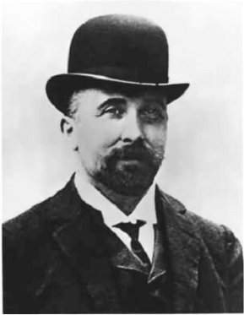
Felix Hoffman (January 21, 1868 – February 8, 1946)
Source: http://upload.wikimedia.org/wikipedia/commons/6/67/Felix_Hoffman.jpg
Aspirin, or acetylsalicylic acid, is a ‘salicylate’ drug that, as well as its best known effect as an ‘analgesic’ to reduce aches and pains, can also be used as an ‘antipyretic’ to control fever, and as an anti-inflammatory to reduce inflammation. It also has the effect of making the blood less likely to clot, known as anti-coagulation. It was the first ‘non steroidal anti inflammatory drug’ to be discovered (another example being ibuprofen), and it had the huge benefits of reducing pain without impairing consciousness and was not addictive unlike opiate painkillers such as laudanum.
- After having read this paragraph, sum up all four medical uses of aspirin :

Part 2 : Synthesis and procedure
Aspirin or acetylsalicylic acid is an acetyl derivative of salicylic acid that is a white, crystalline, weakly acidic substance, with a melting point of 135 °C. Its $pK_{a}$ equals 3.5 at 25 °C.
Synthesis
The synthesis of aspirin is classified as an esterification reaction. Salicylic acid is treated with acetic anhydride, an acid derivative, causing a chemical reaction that turns salicylic acid's phenol group into an acetyl group, ($R-OH$ gives $R - OCOCH_{3}$). This process yields aspirin and acetic acid, which is considered a by-product of this reaction. Small amounts of sulfuric acid (and occasionally phosphoric acid) are almost always used as a catalyst.

- Write the balanced equation :

$$__________________+ __________________=__________________+__________________$$
You can use these cards to balance the equation:
Acetic acid
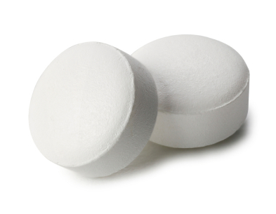

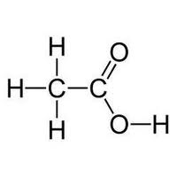
Aspirin = acetylsalicylic acid

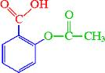
Salicylic acid

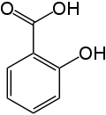
Acetic anhydride

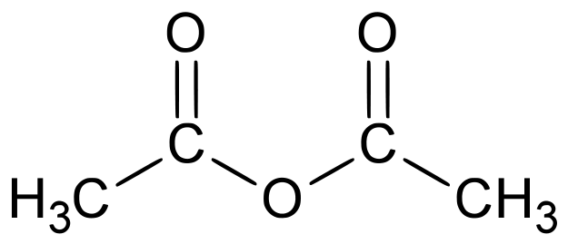

- Using the previous synthesis, find an english equivalent for (connect with arrows):

French | English
ce procédé donne (comme produits) | catalyst
catalyseur | to turn into
transformer en | this process yields

Procedure
Synthesis of aspirin
- Place approximately 4 g of salicylic acid (known to 0.01 g) into a 25 or 50 mL beaker.
- Add 8 mL of acetic anhydride to the beaker.
- Gently swirl the beaker then add three drops of sulfuric acid ($H_{2}SO_{4}$) as the catalyst.
- Heat this mixture in a water bath on a hot plate for 20 min, occasionally stirring with a glass rod.
- Remove the beaker from the water bath and cool for five minutes. SLOWLY add 15 mL of chilled water. Swirl the beaker to insure mixing and place into an ice bath. Crystals of acetylsalicylic acid should begin to form.
- When crystal formation is complete (about 15 - 20 min), vacuum filter your product (using a Buchner funnel). Rinse out the beaker with a small amount of chilled water and then wash your crystals in the funnel with 15mL of chilled water.

Purification and recrystallization
- Transfer your crystals to a 150 - 250 mL beaker. While warming on a hot plate, add warm ethanol, 5 mL at a time, to your crystals until they are completely dissolved (use no more than 20 mL).
- Add about twice as much ice water as you added ethanol and cool the mixture in an ice bath (about 20 minutes). Large quantities of crystals should form if you stir the solution vigorously with a stirring rod.
- Vacuum filter the products, again rinsing with chilled water. Allow to dry while aspirating for 5 min. You may want to weigh the filter paper first.
- Weigh a small beaker (known to 0.01 g). Transfer the crystals to the beaker, weigh the beaker and crystals (known to 0.01 g) to determine the amount of product. Use this value to calculate the percent yield for your reaction.

Using the previous procedure, find an english equivalent for :
French | English
un mode opératoire, procédé
introduire environ 4g
un bain marie
un filtre büchner
agiter vigoureusement
filtrer sous vide
peser … (avec une précision de 0,01g)
le rendement

- Aspirin over time

Part 1: The discovery of aspirin
When chemist Felix Hoffman attempted to lessen his father's chronic stomach pain, he discovered aspirin. Learn more about Hoffman's astonishing career in this video :
http://videos.howstuffworks.com/howstuffworks/35523-infamous-inventors-aspirin-video.htm

Answer the following questions :
- What was Felix Hoffman’s job and for which company did he work?

_________________________________________________________________________________________________

- Where in nature can you find a pain relief agent?

_________________________________________________________________________________________________

- Which molecule did scientists first synthesize to mimic this natural compound?

_________________________________________________________________________________________________

- What was the problem?

_________________________________________________________________________________________________

- Did Hoffman manage to patent his invention?

_________________________________________________________________________________________________

Part 2: The controversial discovery of aspirin
Step 1 : Discovering the recording
mp3 source: http://www.thenakedscientists.com/HTML/content/interviews/interview/1168
Start at 13’15
Stop at “It was not available over the counter until after the turn of the century. “
Listen to the mp3 for further knowledge on aspirin discovery and its true inventor.

Write down the keywords that you hear :

_________________________________________________________________________________________________

Step 2 : Assisted listening
After a couple of listenings without the text, you may listen to the mp3 again but this time, read the text at the same time. Note that the main keywords appear in bold lettering.

Sarah Castor-Perry
“This week in science history saw, in 1897, Felix Hoffman first synthesised a stable form of acetylsalicylic acid for medical use, better known as aspirin.
Aspirin, or acetylsalicylic acid, is a ‘salicylate’ drug that as well as its best-known effect as an ‘analgesic’ to reduce aches and pains can also be used as an ‘antipyretic’ to control fever, and as an anti-inflammatory to reduce inflammation. It also has the effect of making the blood less likely to clot, known as anti-coagulation. It was the first ‘non steroidal anti inflammatory drug’ to be discovered (another example being ibuprofen), and it had the huge benefits of reducing pain without impairing consciousness and was not addictive unlike opiate painkillers such as laudanum.
Salicylate based medicines derived from plants like meadowsweet and willow trees had already been in use for over three and a half thousand years by the 19th century, to reduce aches and pains and fever. In fact the name ‘salicylic acid’ comes from the Latin name for the willow tree, Salix. In the 1820s and 30s, chemists in Italy and Germany managed to purify the active chemical found in these plants – salicylic acid. The medicinal use of this grew in the mid 1800s, but it did have several drawbacks, including the fact that it caused stomach pain, ulcers and even stomach bleeding.
Around this time, an industry began to grow in Germany to investigate medicines that could be derived from cloth dyes made from coal tar. Surprising as it might sound given the starting point of coal tar, a lot of compounds were found that could be used to reduce fever and pain. A German dye firm called Friedrich Bayer and Company began to expand to investigate medicines further, seeing that there was money to be made. It was this company that Hoffman joined as a young man in 1894, to work with two chemists called Eichengrün and Dreser.
In 1897, Eichengrün instructed Hoffman to find an alternative form of salicylic acid that would be less irritating to the stomach, but would still produce anti fever and pain effects. In his lab book entry for the 10th of October 1897, Hoffman declared that he had synthesised a pure form of acetylsalicylic acid by refluxing salicylic acid with acetyl anhydride. This ended up producing a much purer and more stable form of acetylsalicylic acid than had been produced before, using other techniques. Clinical trials suggested that it was just as effective as salicylic acid without many of the unpleasant side effects. However, it was not until 1899 that the name Aspirin was decided on and the Bayer began producing it for use as a prescription drug. It was not available over the counter until after the turn of the century. “

Part 3: Aspirin in 1918 and the flu pandemic
Can aspirin relieve symptoms of the flu?
Listen to the mp3 regarding the 1918 flu pandemic (start at 0’15) and answer the following questions:
http://www.thenakedscientists.com/HTML/content/news/news/1819

- What is today’s production of aspirin around the world ?

- Which doses of aspirin were given to flu patients ?

- What was the effect ?

Part 4 : Building a time frame
Summarize in a time frame the different steps and actors in aspirin discovery

Presenting the time frame.
A couple of volunteer students should present the time frame to the rest of the class. Take some time to write down your presentation, test it with a classmate, then give it in front of the class.

- Industrial production of aspirin
Here is a flow diagram of aspirin synthesis.
www.wikimediacommons.org

Summarize the main steps of aspirin synthesis:
1) __________________
2) __________________
3) __________________
4) __________________
5) __________________
6) __________________

Activity summary
What you must remember :
- vocabulary associated with aspirin synthesis
- Felix Hoffman was the inventor of aspirin

Skills linked to the curriculum :

Compétences | Capacités à maîtriser
- APP  - ANA | - Connaître le vocabulaire lié à la synthèse organique
- COM | - Expliquer un procédé de synthèse

Flu pandemic : Pandémie de grippe

