CH5: Synthesis and the environment

1. Hemisynthesis of Taxotere®

### Cancer Therapy and Canada Yew

The Pacific Yew and Canada Yew both produce a class of chemicals called taxanes, chemicals that are currently being used to fight cancer. Canada Yew can be found in forests of Eastern North America.

<https://www.youtube.com/watch?v=fhGHk5mEYbw>

Watch the video and answer the following questions:

1. **40 to 49 seconds**: What does the narrator explain about cancer therapy? (Put the words in the right order)

discovered – comes – that – it turns out – from – one of – plant – cancer therapies – a very ordinary – the most powerful

1. **1’51 to 2’18**:

* What is the name of the small conifer found in forested areas throughout northeastern North America?
* What is the plant’s botanic name?
* What is the class of chemicals produced by this conifer?
* Where are these complex molecules found in the plants?

1. **2’18 to 2’25**: What is the name of one of these complex molecules used in cancer therapy?
2. **2’39 to 2’47**: What is the problem with the synthesis of taxane’s molecules? (Put the words in the right order)

the best factory – itself – to synthesize – these – are difficult – chemotherapy drugs – so – taxanes – the plant – for – remains – producing

1. **3’33 to 4’16**:

* What does the Canada Yew protect ? Why ?
* Put the words in the right order : harvesting – Canada Yew – a reprieve – has given – from – the Pacific Yew

### Growing Canada Yew in Plantations

**DOCUMENT 1 : Growing Canada Yew in Plantations : Profitable or Not ?**

Authors : Thomas L. Noland and Mamdouh Abou-Zaid

Canada yew is a low evergreen shrub that is native to eastern Canada. Over the past five years, demand for yew biomass in general has increased dramatically, because it contains chemicals called taxanes that are used to make important anti-cancer drugs.

One of these taxanes is paclitaxel, the active chemical in chemotherapy drugs such as Taxol®, which is used to treat breast, ovarian, and non-small cell lung cancers as well as Kaposi's syndrome, an AIDS-related cancer. In 2000, while still under patent, paclitaxel was the world's most valuable anti-cancer drug, with sales peaking at US $1.6 billion and current sales running at about US $1 billion per year. Worldwide demand for paclitaxel and newer second-generation taxane drugs such as Taxotere® and Abraxane® is rising by about 10 % per year.

Most of the demand for taxanes is now met with biomass from English yew plantations in Europe, US, and Asia. In Canada, however, wild Canada yew is in demand, as its foliage, bark, twigs, and roots contain relatively high levels of taxanes, particularly paclitaxel. Unfortunately, Canada yew, the last significant source of wild yew biomass in the world, is not always harvested sustainably. Given the high taxane levels in Canada yew and concerns about wild harvesting, we asked the question : How can we best grow and harvest this shrub in plantations ?

[**http://www.silviculturemagazine.com/articles/fall-2009/growing-canada-yew-plantations-profitable-or-not**](http://www.silviculturemagazine.com/articles/fall-2009/growing-canada-yew-plantations-profitable-or-not)

1. What are the three different commercial names of chemotherapy drugs given in this text?
2. Why can we say that Taxotere® and Taxol® are biosourced products?
3. Is the Taxotere® molecule biologically active? Explain.

### Hemi-synthesis

**DOCUMENT 3 : Synthesis of Taxol® and Taxotere®**

The DAB III molecule has no anti-cancer activity, but can be a reagent for Taxol® hemisynthesis. The first step consists in replacing the DAB III hydrogen atom (shown in the diagram below) with a cinnamic acid moeity. In a second step, further chemical modifications of the molecule obtained from step 1 give either Taxol® or Taxotere®.

|  |  |
| --- | --- |
| **DOCUMENT 2 : How have chemists managed to synthesize such a complex molecule, Taxotere® ?** | |
|  |
| At best, a hundred-year-old yew tree can produce 3 kg of bark, or 300 mg of Taxol®. Even by optimizing the extractive process, the production of 1 kg of Taxol® requires about 7 tonnes of bark and the treatment of a single patient for 1 year requires on average the slaughter of 3 trees. We can not therefore consider an industrial production of the molecule without, in the long term, destroying the species.  Thus, between 1983 and 1993, more than thirty teams worked on the synthesis of Taxol®. During the development of this synthesis, they devised another molecule, Taxotere®, a Taxol® cousin, but twice as effective and with fewer side effects than this one.  Different operating possibilities have been considered and tested to produce Taxotere®. Only one has been selected to produce it in larger quantities : European yew leaves [Latin name: Taxus baccata]. Easily renewable raw material, they contain, in a significant amount (from 0.02 to 0.1%), the cyclic part of the molecule of Taxotere®: 10-deacetatylbaccatin III or DAB III. Taxotere® is then prepared by hemisynthesis from this structural analogue, DAB III. | |

[**http://www.silviculturemagazine.com/articles/fall-2009/growing-canada-yew-plantations-profitable-or-not**](http://www.silviculturemagazine.com/articles/fall-2009/growing-canada-yew-plantations-profitable-or-not)

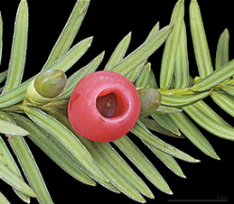

*European yew leaves (Taxus Baccata)*

[*https://fr.wikipedia.org/wiki/Taxus*](https://fr.wikipedia.org/wiki/Taxus)

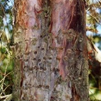

*Taxus brevifolia Nutt. Pacific yew*

[*http://plants.usda.gov/core/profile?symbol=tabr2*](http://plants.usda.gov/core/profile?symbol=tabr2)

***DAB III***

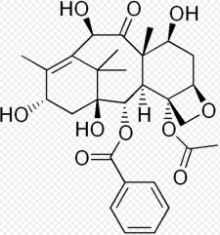

[*https://en.wikipedia.org/wiki/10-Deacetylbaccatin*](https://en.wikipedia.org/wiki/10-Deacetylbaccatin)

***Taxotere®***

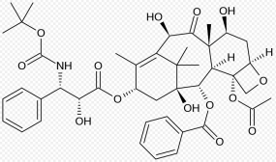

[*https://en.wikipedia.org/wiki/Discovery_and_development_of_tubulin_inhibitors*](https://en.wikipedia.org/wiki/Discovery_and_development_of_tubulin_inhibitors)

***Taxol®***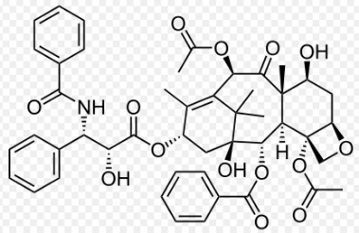

[*https://fr.wikipedia.org/wiki/Paclitaxel*](https://fr.wikipedia.org/wiki/Paclitaxel)

**DOCUMENT 4 : Hemisynthesis**

Not all drugs can be obtained by pure chemical synthesis. Most natural products have such complicated structures that it would be too difficult, environmentally unfriendly and costly to synthesize them on an industrial scale. In our case, the cyclic part of the molecule of Taxotere®, DAB III, is extracted from European yew leaves. From this cyclic molecule the hemi synthesis, which includes more than 40 steps, is carried out and Taxotere® is obtained.

A step of the synthesis of Taxotere® :

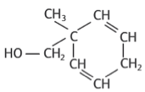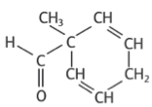



The researchers had to develop different strategies of synthesis to find the optimal conditions for each step.

*Physique-Chimie Nathan 1èreS*

**Using the documents provided, answer the following questions :**

1. Why can we say that the Taxotere® molecule is “complex”?
2. Why have researchers worked on the synthesis of Taxotere® whereas Taxol® of natural origin was already available?
3. Why is it said that Taxol® and Taxotere® synthesis, from the DAB III molecule, are hemi syntheses?
4. What is the advantage of a hemi synthesis compared to a total synthesis?
5. Is the Taxotere® synthesis easy? Explain.
6. Which characteristic group is modified during the step described in document 4? Into which group is it transformed

To which family of chemical reactions does this step belong?

1. The operating conditions of each step were established after lots of tests and must be strictly respected.

Is the step presented in document 4 easily achievable?

### Green chemistry

**DOCUMENT 5 : 12 Principles of Green Chemistry**

Maximize incorporation of materials

Waste prevention better than clean-up

Lower toxicity

Design safer chemicals

Don’t use solvents!

Accident prevention

Monitor and analyse

Design for degradation

Use catalysis

No protecting group chemistry

Minimise energy

Use renewable sources

**12 Principles of Green Chemistry**

1. Because of which facts is the commercialization of Taxotere® and Taxol® an example of the application of chemistry to sustainable development?
2. Which of the 12 principles of green chemistry is(are) used in the synthesis of Taxotere® and Taxol®?
3. Give three objectives that need to be met during complex molecules synthesis?

Activity summary

What you must remember :

* vocabulary associated with hemisynthesis

Skills linked to the curriculum :

|  |  |
| --- | --- |
| **Compétences** | **Capacités à maitriser** |
| * ANA * COM | |  | | --- | | * Citer les exigences en matière de chimie « verte » ou durable, en ce qui concerne les choix des matières premières, des réactions et des procédés, ainsi que d’éco-compatibilité du produit formé. | |
| * APP * COM | * Citer quelques utilisations importantes des agroressources en synthèse organique et exploiter des documents pour illustrer leur part croissante en tant que matières premières |
| * APP * ANA * COM | * Reconnaître une hémisynthèse dans la description d’un protocole. |