CH4 : Separation and purification
- Recrystallization – main steps
DOCUMENT 1 : Recrystallization video
MIT Open Course Ware : Recrystallization
https://ocw.mit.edu/resources/res-5-0001-digital-lab-techniques-manual-spring-2007/videos/

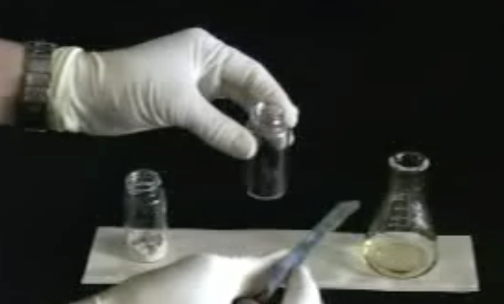

Part 1 : DISSOLUTION OF SAMPLE, DECOLORATION AND HOT FILTRATION
- Using a video:
Watch video “Recrystallization” from the MIT online learning course. (Start at 4min40s end 9min55s)
Rephrase the main steps and explain:

- Acquiring vocabulary: filling in the blanks
English | French
 | Grains de pierre ponce
To clamp
To tip over
 | Une impureté
Activated charcoal
To absorb
To swirl
 | Entonnoir
Filter paper
 | Un montage de filtration sous vide
The mother liquor

- Labelling the document: the vacuum filtration setup
Using the vocabulary help, label the following document:
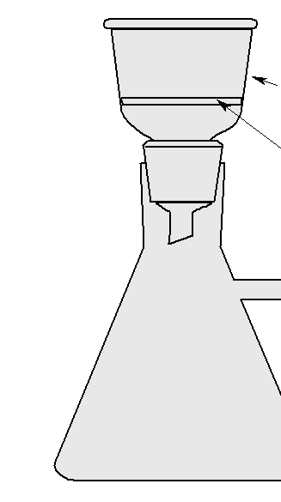

Part 2 : COOLING, CRYSTALLIZATION
- Using a video:
Watch video “Recrystallization” from the MIT online learning course. (Start at 10min end 12min50s)
What is the objective in this lab experiment?
- Acquiring vocabulary: filling in the blanks
English | French
Crystal growth
 | Une astuce pour déclencher le procédé
 | Amorcer
 | Tremper un barreau en verre
To drive to completion
To scrape | Gratter
Weighing dish
RT : room temperature
An oven
A dessicator

- Using a document:
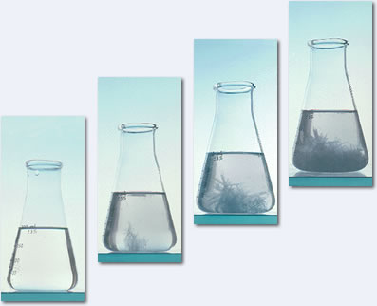
www.wikimediacommons.org
What happens in the above document? Present the results using the given vocabulary.
__________________________________________________________________________________

Activity summary
What you must remember :
- vocabulary associated with recrystallization
- the main steps of recrystallization

Skills linked to the curriculum :

Compétences | Capacités à maitriser
- APP | - Connaître le vocabulaire lié à la recristallisation
- ANA  - COM | - présenter une cristallisation

