CH4: Separation and purification
- Recrystallization – choosing the right solvent
DOCUMENT 1 : Recrystallization video
MIT Open Course Ware : Recristallisation
https://ocw.mit.edu/resources/res-5-0001-digital-lab-techniques-manual-spring-2007/videos/

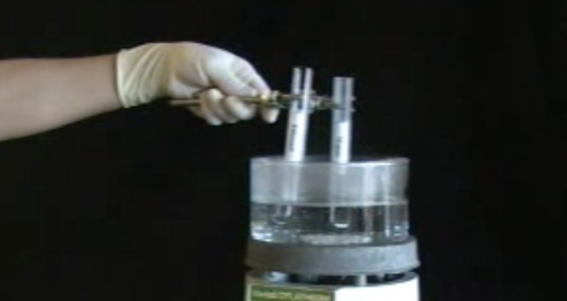

Studying a video

Watch video “Recrystallization” from the MIT online learning course. (Start at 50s end 4min40s)
What does the video deal with? ____________________________
List the main steps of recrystallization:
_________________________________________________________________
_________________________________________________________________
_________________________________________________________________

Learning vocabulary: filling in the blanks

English | French
hot water bath
solvent
solute
flammable
crystallizing dish
solubility test

Choosing the right solvent :
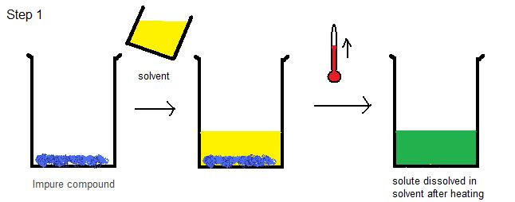
What is the ideal solvent in the video? Why? Explain.
_________________________________________________________________

Presenting
Prepare a 1min presentation of the choice of solvent
_________________________________________________________________________________________________
_________________________________________________________________________________________________
_________________________________________________________________________________________________
_________________________________________________________________________________________________

Activity summary
What you must remember:
- vocabulary associated with choosing a solvent during recrystallisation
- how to choose a solvent

Skills linked to the curriculum:

Compétences | Capacités à maitriser
- APP | - Connaître le vocabulaire lié à la recristallisation
- ANA  - COM | - Effectuer et présenter un choix de solvant

