CH3: chemistry and the environment
This activity is based on the movie « The Inconvenient Truth » which should be purchased on DVD or downloaded through legal means.
- The Inconvenient Truth

Part 1: Website
Visit the website http://an-inconvenient-truth.com
Al Gore, ex vice president of the United States, presenting his slide show in the documentary The Inconvenient Truth

Source: https://commons.wikimedia.org/wiki/File:AlGoreGlobalWarmingTalk_Crop1.png?uselang=fr

In your opinion, what does the movie « The Inconvenient Truth » deal with?
_________________________________________________________________________________________________
_________________________________________________________________________________________________

In the section, « what you can do », find some ideas of things we can do in our every life in order to preserve the environment :
_________________________________________________________________________________________________
_________________________________________________________________________________________________
_________________________________________________________________________________________________
_________________________________________________________________________________________________

Part 2: Vocabulary test
Suggest a meaning for the following words :
English | French

Global warming

Greenhouse gases

To trap

To thicken

A trend

To fluctuate

To behave as though it were…

According to…

To be receding

To be retreating

The amount of CO₂

A link

An ice shelf

The thickness

A phenomenon

To be abundant

A virus carrier

Land based melting ice

Sea rise

to evolve

- The Inconvenient Truth, the movie part 1

Part 3: Questions and answers
Watch the movie starting at 9’00 and answer the questions as you go along.
9’00-10’00
- What is the basic science about global warming?

_____________________________________________________________________________________________
_____________________________________________________________________________________________
10’00-11’36

_____________________________________________________________________________________________
_____________________________________________________________________________________________
12’00-14’00 Research results
14’00-15’00
- What is the trend that is being followed by CO₂ concentration in the atmosphere? Why does the amount of CO₂ fluctuate each year?
_____________________________________________________________________________________________
_____________________________________________________________________________________________
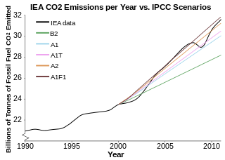
Source :
https://en.wikipedia.org/wiki/Global_warming
16’25-
- What is the effect of global warming on the planet (according to this part of the movie)?
_____________________________________________________________________________________________
_____________________________________________________________________________________________

18’30-
- How do you measure the amount of CO₂ and temperature for each year?
_____________________________________________________________________________________________
_____________________________________________________________________________________________

20’30-
- What is the trend that is being followed by CO₂ level in the atmosphere? What is the link between the temperature curve on earth and the CO₂ concentration?
_____________________________________________________________________________________________
_____________________________________________________________________________________________

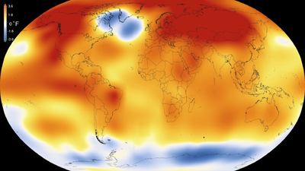
Source :
https://en.wikipedia.org/wiki/Global_warming
- The Inconvenient Truth, the movie part 2
22’35-24’50
- In the past thousand years what has the maximum amount of CO₂ been?
_____________________________________________________________________________________________
_____________________________________________________________________________________________
- What is it now? What will it be in the next 50 years if nothing is done?
_____________________________________________________________________________________________
_____________________________________________________________________________________________

37’00-39’00
- How does this affect our climate?
_____________________________________________________________________________________________
_____________________________________________________________________________________________

44’00-
- What is the effect on the thickness of the sea ice shelf? What is the phenomenon observed?
_____________________________________________________________________________________________
_____________________________________________________________________________________________
Source :
https://en.wikipedia.org/wiki/Global_warming
Sea ice, shown here in Nunavut in northern Canada, reflects more sunshine, while open ocean absorbs more, accelerating melting.

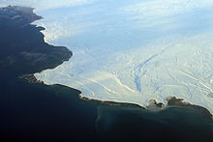

51’30-
- What will be the effects on insects?
_____________________________________________________________________________________________
_____________________________________________________________________________________________

55’00-
- What is the effect on the ice shelf (study of the Larsen ice shelf in Alaska)?
_____________________________________________________________________________________________
_____________________________________________________________________________________________

56’40-
- What is the effect on sea level of a melting floating iceberg and of land based melting ice (glacier)? Explain using a diagram.
_____________________________________________________________________________________________
_____________________________________________________________________________________________

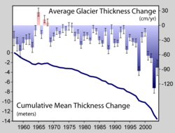
Source :
https://en.wikipedia.org/wiki/Global_warming
Sparse records indicate that glaciers have been retreating since the early 1800s.
59’20-
- If half of Greenland and half of West Antartic were to melt, what would happen?
_____________________________________________________________________________________________
_____________________________________________________________________________________________

1hr03’40’’-1hr09’40’’
- Why are we in this century putting recent pressure on the Earth?
_____________________________________________________________________________________________
_____________________________________________________________________________________________

1hr07’57’’
- What are the contributions to global warming around the world?
_____________________________________________________________________________________________
_____________________________________________________________________________________________

1hr08’36”
- Why does Al Gore compare us all to frogs?

_____________________________________________________________________________________________
_____________________________________________________________________________________________

1hr30’-1hr33’ What can we do to protect the Earth?

_____________________________________________________________________________________________
_____________________________________________________________________________________________

Activity summary
What you must remember :
- vocabulary associated with air and water pollution

Skills linked to the curriculum :

Compétences | Capacités à maitriser
- APP  - ANA  - COM | - Citer des implications de la chimie dans des études menées sur l’environnement ou des actions visant à le préserver

