CH2: taking safety into account
- Lab safety

Personal Protective Equipment (PPE)

Watch the two videos in order to find out the PPE you have to wear in a laboratory:
- PPE_Lab_Safety_video_Part1 :
https://www.youtube.com/watch?v=GjAD83B4JaY
- Health and Safety Essentials : Laboratory Best (from the beginning to 1’33)
https://www.youtube.com/watch?v=RhlOYhOvCsQ

- Find out the right PPE in a lab and fill in the diagram below :

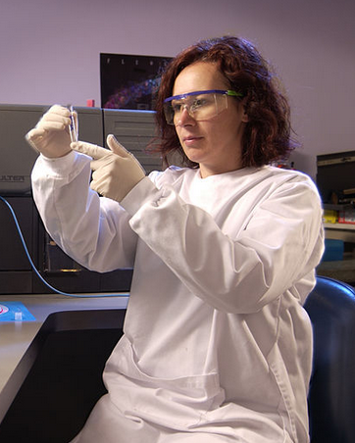

Sources : wikimedia commons

Safety equipment

Watch the video in order to find out the safety equipment available in a general chemistry lab:
Equipment / Lab Safety Video Part 2 : https://www.youtube.com/watch?v=IiHEYtnKfF0

- Find out the safety equipment found in the lab and complete the picture below :

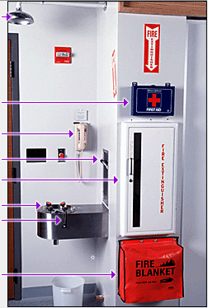
https://www.dartmouth.edu/~chemlab/info/safety/equipment.html

- What is the eyewash station used for ?
- How long do you have to rinse your eyes in the eyewash station ?
- What are the 4 types of fire ?

Your behavior in a lab

Watch the video in order to find out the appropriate behavior in a chemistry lab :
Behavior/Lab Safety Video Part 3 : https://www.youtube.com/watch?v=e7VkIuiT1kU

- How should you behave in order to ensure that the lab is a safe environment for everyone? (Fill in the blanks)

- First consideration is to follow the written ……………………………………………………………………………… step-by-step
- Never ………………,………………………,……………………………. or ………………………………………………… while in the lab
- Never …………………………………………………….
- Good ……………………………………………
- Never place any chemical bottles ……………………………………………………
- If you do make a spill, check the ……………………………………………………….. for the appropriate response. And clean it immediatly and place a ………………………………………………. sign
- Keep your …………………………………………………………………………………
- Don’t place materials ………………………………………………….. of the workbench
- Never try to ………………………………………………………………………………………….. and dispose the glass in a designated ………………………………………………………………………………..
- After you’ve finished an experiment, …………………………………………………………, return reagents ……………………………………………………….. and clean …………………………………………………………………..
- If a safety violation occurs, or you notice any unsafe condition in the lab, report it immediately to …………………………………………………………………………………..

Interactive eLearning Tools => Lab Safety

To conclude this activity, you have to obtain your certificate of completion.

It will prove that you know how to :
- Dress properly before entering the lab
- Locate lab safety equipment in your own lab
- Keep your lab clean and free of clutter
- Respond to hazardous situations
Go to :
http://www.ncbionetwork.org/educational-resources/elearning/interactive-elearning-tools/lab-safety
Then « launch App »
Then « Enter the lab »
Then follow instructions and do successively :
- Proper Dress
- Housekeeping
- Safety Equipment
- Mixing
- Fire Safety
- Spills
- Conclusion

At the end of the activity :
- Click « View Certificate » to print your certificate of completion
- Click « Print Lab Notes » to obtain your Lab Notes

Activity summary

What you must remenber :
- Vocabulary associated with PPE, Safety equipment and behavior in a lab

Skills linked to the curriculum:
Compétences | Capacités à maîtriser
- APP | - Connaître et savoir appliquer les règles de sécurité au laboratoire  - Savoir adopter une attitude responsable au laboratoire
- ANA | - Savoir réagir face à une situation dangereuse au laboratoire, d’une manière autonome

