Sequence n° 1:

CH1 Applications of chemistry and their evolution
- Evolution of gin distillation
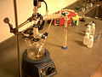
DOCUMENT 1 : Simple distillation
www.wiredchemist.com www.wikimediacommons.org
Simple distillation is a procedure by which two liquids with different
boiling points can be separated. Simple distillation (the procedure
outlined below) can be used effectively to separate liquids that have at least fifty degrees difference in their boiling points. As the liquid being distilled is heated, the vapors that form will be richest in the component of the mixture that boils at the lowest temperature. Purified compounds will boil, and thus turn into vapors, over a relatively small temperature range (2 or 3°C); by carefully watching the temperature in the distillation flask, it is possible to affect a reasonably good separation. As distillation progresses, the concentration of the lowest boiling component will steadily decrease. Eventually the temperature within the apparatus will begin to change ; a pure compound is no longer being distilled. The temperature will continue to increase until the boiling point of the next-lowest-boiling compound is approached. When the temperature again stabilizes, another pure fraction of the distillate can be collected. This process can be repeated until all the fractions of the original mixture have been separated.
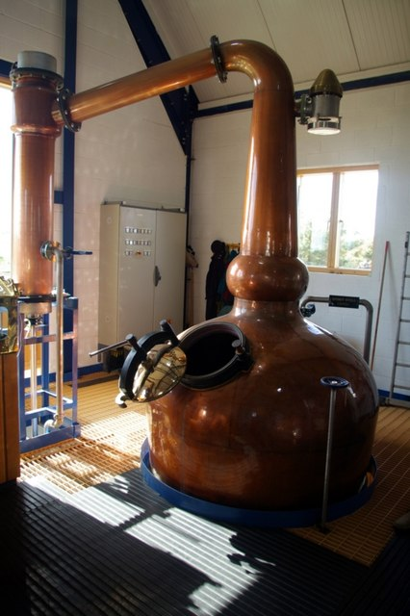
DOCUMENT 2 : Gin Production through traditional fractional distillation
http://www.ginvodka.org/history/ginProduction.asp
www.wikimediacommons.org
[..] The still is heated, using a steam coil or jacket, to remove the essential oils (less than 5% of the weight) which give the flavouring to the spirit. The first distillate 'runnings' are re-circulated until an appropriate standard and strength (over 90 % ABV) is reached. The lower quality early part of the run ('foreshots') and end of the run ('feints') [..] are run off to be redistilled. Only the 'middle run' is used to produce high quality gin ; this is run off at about 80-85% ABV. The product then goes through a quality control 'Tasting Panel' and may also be analysed by gas chromatography to ensure that it meets the required specification. This ensures product consistency. [..]
The gin is then brought to the required EU legal minimum alcohol level - at least 37.5 % ABV, - by the addition of pure demineralised water. It is now ready for bottling as it does not require any period of maturation.
High vacuum distillation setup
www.wikimediacommons.org

DOCUMENT 3: Comparison of a novel distillation method versus a traditional distillation method in a model gin system
Greer D1, Pfahl L, Rieck J, Daniels T, Garza O.
This research studied a novel form of distillation (high vacuum distillation) as a method for preserving volatile aroma chemicals important to the organoleptic attributes of a four botanical model gin as well as the degradation products generated during the heating required in traditional methods of gin distillation. A model gin was made of dried juniper berries (Juniperus communis), coriander seed (Coriandrum sativum), angelica root (Angelica archangelica), and dry lemon peel (Citrus limonum). This was distilled on a traditional still utilizing atmospheric pressure and a heating mantel to initiate phase separation as well as a novel still (high vacuum) utilizing high vacuum pressures below 0.1 mmHg and temperatures below -15 degrees C to initiate phase separation. The degradation products (alpha-pinene, alpha-phellandrene, E-caryophyllene, and beta-myrcene) were present at greater levels (approximately 10 times) in the traditional still-made gin as compared to the novel gin.

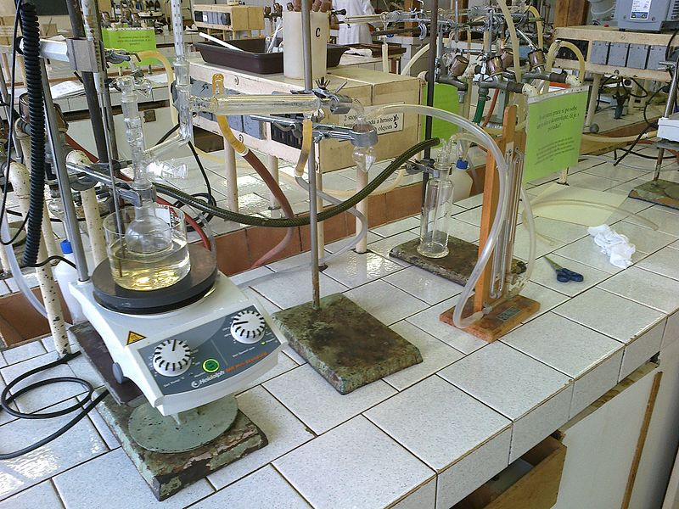
DOCUMENT 4: Gin at the liquor store
www.wikimediacommons.org
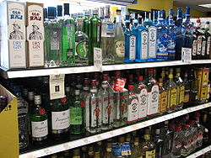
Vocabulary
Using the previous documents, fill in the blanks :
French | English
une méthode, un procédé
temperature d’ébullition
un mélange
un montage
la première “coupe”
 | a still
 | abv : alcohol by volume
 | a novel method
 | degradation products

Questions
Which three distillation techniques are presented in the documents?
_________________________________________________________________________________________________
_________________________________________________________________________________________________
_________________________________________________________________________________________________

Explain the differences in all three methods.
_________________________________________________________________________________________________
_________________________________________________________________________________________________
_________________________________________________________________________________________________
_________________________________________________________________________________________________
_________________________________________________________________________________________________

According to document 3, what seem to be the advantages of high vacuum distillation compared to traditional still distillation?

_________________________________________________________________________________________________
_________________________________________________________________________________________________
_________________________________________________________________________________________________
_________________________________________________________________________________________________
_________________________________________________________________________________________________
_________________________________________________________________________________________________

Presentation
Prepare a 5 min presentation of the simple distillation method.
_________________________________________________________________________________________________
_________________________________________________________________________________________________
_________________________________________________________________________________________________
_________________________________________________________________________________________________

Activity summary
What you must remember :
- vocabulary associated with distillation
- All three distillation techniques presented

Skills linked to the curriculum :

Compétences | Capacités à maîtriser
- APP  - ANA | - Connaitre l’intervention de la chimie dans divers domaines de la vie courante
- ANA  - COM | - Citer l’évolution d’une technique au cours des siècles  - Savoir présenter une technique
- APP  - ANA | - Citer des choix opérés pour répondre à des besoins sociétaux et/ou économiques

