Sequence 1: safety and environment
Fiches de synthèse mobilisées (collection en français) :
- Fiche n°1 : sécurité et environnement
Sommaire des activités ETLV : chapitre 2
- ACTIVITY 1: Lab safety
- ACTIVITY 2: Identifying chemical hazards
- ACTIVITY 3: Glassware and equipment
- ACTIVITY 4: Reading protocols

ACTIVITY 3: Glassware and equipment
Objective: acquiring vocabulary on lab equipment
- Label the different pieces of glassware and equipment in English AND in French!
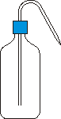 | 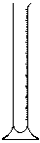
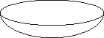 |  |  |  |  |  | 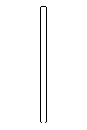
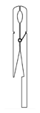 | 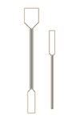 |  | 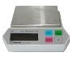 | 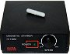 | 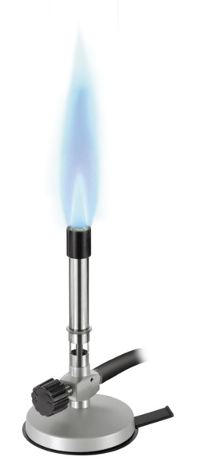 | 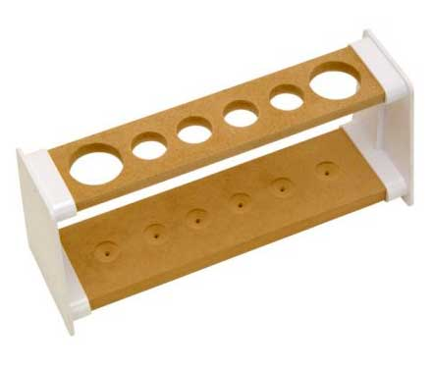

Organic chemistry specific glassware:
 |  |  |  | 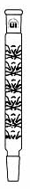
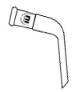 | 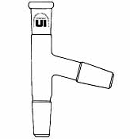 |  | 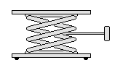 |  | 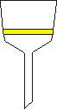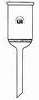 | 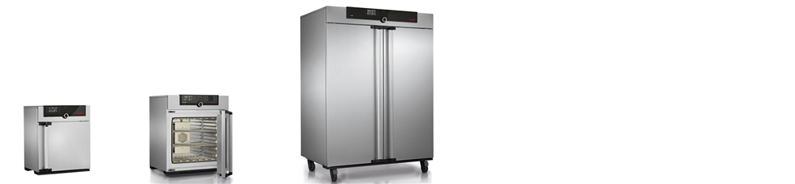
PPE and Equipment :
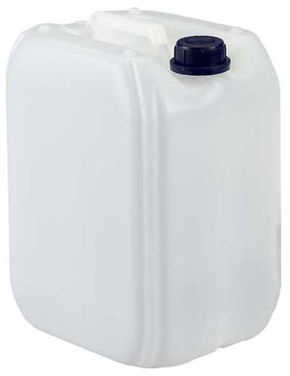 |  | 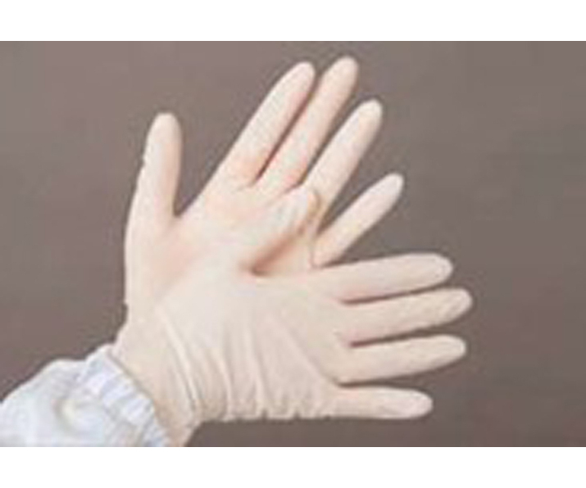 |  | 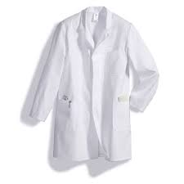 |  | 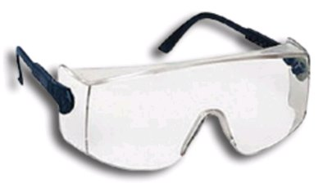

If you need help, you can use website :
https://fr.wiktionary.org/wiki/Annexe:Mat%C3%A9riel_de_laboratoire_en_anglais
- Fill in the blanks:
Used when the experiments require small amounts of matter
Flask calibrated by a cylindrical form, used for measuring the volume of a liquid / approximate volume
It is filled with the titrant when you perform a titration
Wear them in a lab to protect hands from the chemical products. Do not use near fire.
It is used with any laboratory balance to accurately weigh your solid samples.
It is used to separate the solid particles in suspension in a heterogeneous mixture with filter paper.
Device designed to measure one small accurate volume
It’s a flask calibrated to contain a precise volume. These flasks are used for precise dilutions and preparation of standard solutions.
Conical flask often used for titration: it contains the reactant or analyte (reagent) whose concentration is unknown.
Always wear it in a lab to protect eyes against chemical projections.
A wide cylindrical glassware with a pouring lip, used as a lab container and mixing jar.
Never measure with it !!!!!!!!!
Always wear it when handling chemical products and performing experiments.
Plastic wash bottle for distilled water
Device avoiding the need for mouth pipetting
To store test tubes on the bench (lab bench)

- Let’s play now!
Get into groups of 3 or 4 students. Each group has 15 post-it notes with 15 words.
You have to find the glassware in the lab and deposit post-it notes on the glassware as quickly as possible. Each group chooses its leader, when the whole group agrees with the translation then the leader has to go and put all post-it notes on the equipment.
Each group will be timed and time will be added or deducted depending on your answers:
WRONG ANSWER: +10 s
CORRECT ANSWER: - 10 s

ACTIVITY 4: Reading a protocol
Objective: acquiring vocabulary related to protocols
- Read the following protocol and highlight chemistry specific action verbs:

Extraction of Curcuminoids from curcuma
Curcumin, the active ingredient and coloring agent of the Indian spice turmeric is better known since ages for its therapeutic properties. Curcumin gained much attention due to its potent biological properties to treat traumas like Alzheimer’s disease, cancer, inflammations, cystic fibrosis and as an antioxidant. Though generally called as curcumin or curcuminoids, this is a mixture of three compounds namely curcumin, demethoxy curcumin and bis-demethoxy curcumin. Turmeric or Curcuma Longa L is cultivated widely in Southeast Asia. Curcumin content of these varieties varies from 2.8 to 9.3 percent. Turmeric roots or fingers are preprocessed before extraction. Curcumin is generally separated from turmeric oleoresin-the left out after extraction with suitable solvents like ethanol, acetone or ethyl acetate and finally removing the solvent.

Conventional Extraction of Curcumin
Step 1
Pour 150 ml of ethyl alcohol into a 250 ml Round-Bottom flask attached to a Soxhlet extractor.
Step 2
Fill the Soxhlet extractor with 40 g of turmeric powder. Start extraction by maintaining the temperature at 50 to 60 degrees.
Step 3
Continue extraction for 3 to 4 hours until the solvent which fills the extraction unit is almost colorless.
Step 4
Remove the Soxhlet and concentrate the extract. Ensure that not all ethyl alcohol has evaporated from the extract.
Step 5
Add 50 ml of hexane to the extract and stir the solution using a magnetic stirrer.
Step 6
Add water slowly to the solution. You can now observe curcumin precipitating out. If you add more water, the resin may also precipitate out along with curcumin resulting in a black mass. In this case collect the black mass and repeat steps 5 and 6.
Step 7
Filter out curcumin using suction filtration and recrystallize from ethanol. Check the melting point for purity; pure curcumin melts at 179 to 180 degrees.

- In the protocol, list all action verbs

- Summarize each step in your own words

