Sequence 1: spatial structure of chemical species (test)
Objective: testing your knowledge on optical properties of chiral molecules
DOCUMENT 1: Specific rotation of sugars
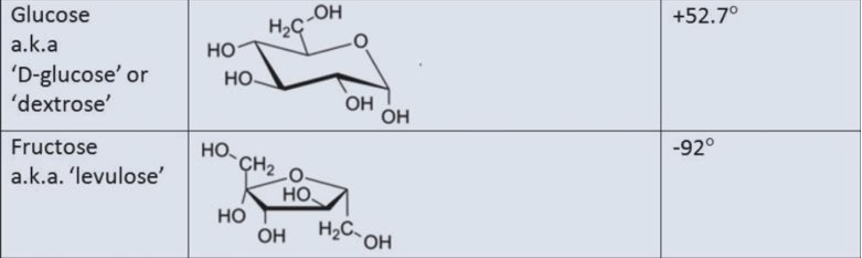
Source: Royal Society of Chemistry

Source: Royal Society of Chemistry

Testing your vocabulary: /10pts
Find a translation for the following expressions:
English | French
specific rotation
 | chiralité
 | sucre
 | filtre polarisant
 | bécher
dextrorotatory
 | polarisé
 | lentille
 | réactif
 | réaction chimique

Reinvesting: /4pts
Explain why fructose and glucose are chiral molecules.
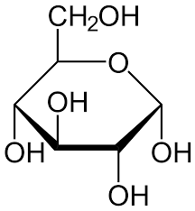
____________________________________________________________________________________________
Glucose Fructose

Which physical property of chiral molecules was illustrated in the video we studied?
_________________________________________________________________________________________________
_________________________________________________________________________________________________

What happens when the scientist rotates the polarising filter behind the two samples? Do both samples behave the same?
_________________________________________________________________________________________________
_________________________________________________________________________________________________

Watching a new video and testing your understanding: /6pts
DOCUMENT 2: Chirality is Just Turtles All The Way Down
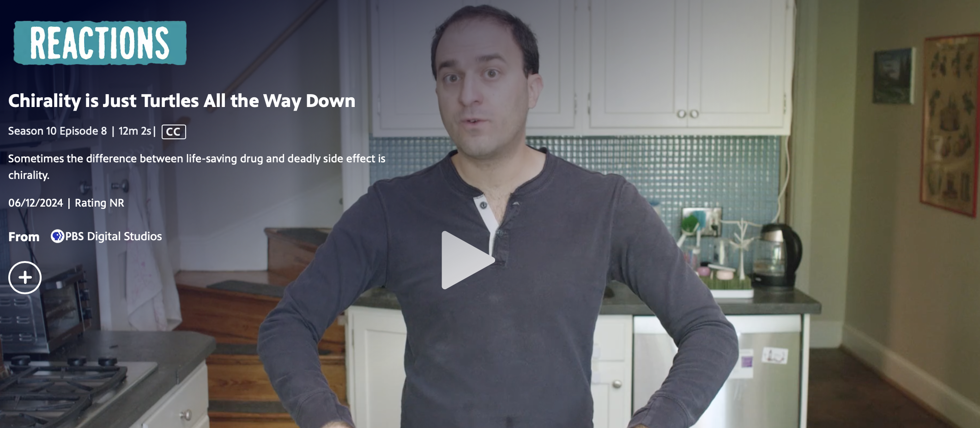
Source: PBS Chemistry
Fill in the blanks: start the video at 1:24

The real molecule you're looking at, that's L-DOPA.
The molecule you're seeing in the mirror, that's D-DOPA.
So L-DOPA and D-DOPA are ______ ________ of each other, and the atom that's responsible for making those two molecules mirror images of each other is this one.
But the thing is, these mirror image molecules are not ___________, and chemists call molecules that are non-super imposable mirror images of each other __________.
And you can see that most clearly if I try to overlap them on each other.
So I'm gonna take this one and rotate it behind this one.
And you can see this oxygen lines up with this oxygen, this hydrogen lines up with this hydrogen, and so on all the way through the molecule, until we get to this carbon right here.
On this one, the nitrogen sticks out towards you.
On the back molecule, the nitrogen sticks out towards me.
And there is no amount of __________ or flipping or anything that I can do in three dimensions that will turn this front molecule into this back molecule.
These atoms will never ____________.
And so these in fact are two __________ ___________.

