Sequence 2: Twelve women in chemistry

ACTIVITY 1: Celebrating women in science
Objective: learning about leading women researchers whose career evolves around chemistry and whose work contributes to today’s research breakthroughs.
Outline of the activity:
You will create a presentation of a female researcher and present it to the class.

Choosing your scientist:
11 February 2025 was International Day of Women and Girls in Science. To mark this occasion, you will highlight twelve women in chemistry.
For this purpose, you will choose from the twelve women presented in the Twelve Women in Chemistry document or in the Women of the Periodic table document (both are courtesy of CompoundInterest https://www.compoundchem.com/infographics/):

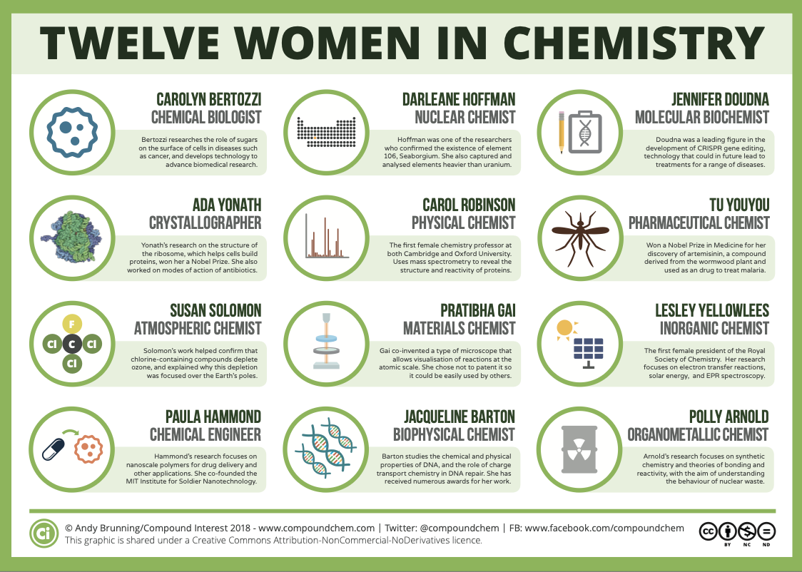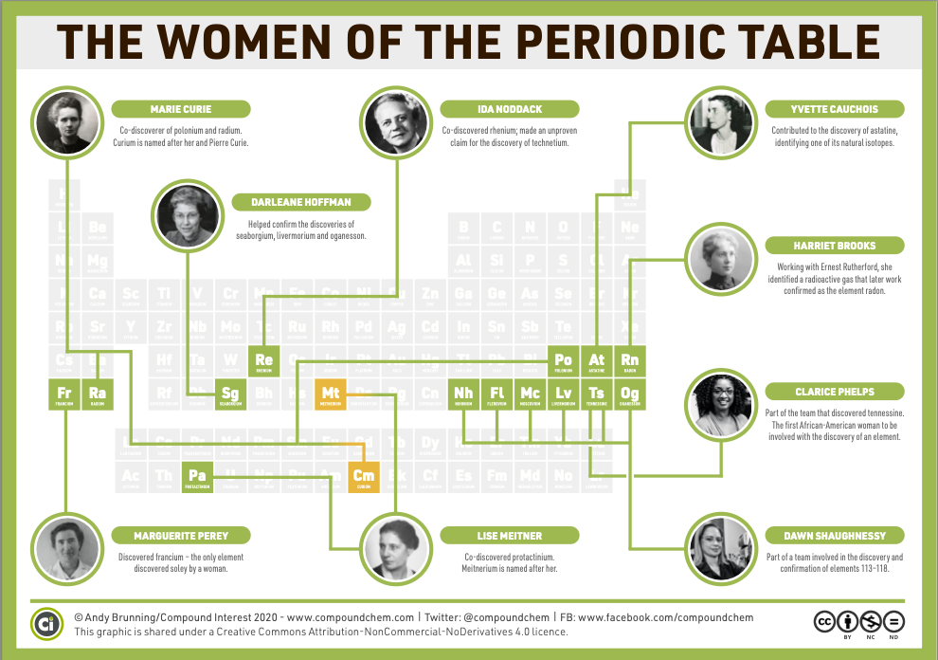
The summaries in the graphics are necessarily succinct, however, if you want to find out more about any of the chemists featured, you can find some articles of interest below:
https://www.compoundchem.com/2018/03/07/12-women-chemistry/

Starting your research:
Search on the Internet and then list the useful websites you select:

Référence du document  (titre, nature du document) | Evaluation  (fiabilité, pertinence, intérêt, actualité, agrément...) | Mots clés | Idées essentielles apportées

Preparing your slides:
Prepare three slides maximum that deal with the following points:
- Name of the scientist and nationality,
- Scientific career of this woman and important dates in her work
- Why her work is/was important in scientific history

You are then to present your research to the class and speak for about 2-3 minutes. No script allowed, but you should use the slides you prepared.

Concluding:
To conclude, write a few sentences highlighting similarities between the scientists you learned about. Give comparisons and be careful using comparatives.

_________________________________________________________________________________________________
_________________________________________________________________________________________________
_________________________________________________________________________________________________
_________________________________________________________________________________________________
_________________________________________________________________________________________________
_________________________________________________________________________________________________

Activity summary
What you must remember:
- A scientist, a researcher
- Scientific history, scientific advances

Skills linked to the curriculum:

Compétences | Capacités à maîtriser | Où dans cette séquence ?
APP | Utiliser du vocabulaire spécifique | Activité 1
 | Lire et comprendre des documents, des sites internet, en discerner la pertinence | Activité 1
COM | S’exprimer à l’écrit et à l’oral en utilisant le vocabulaire adapté | Activité 1

