Sequence 5: movement and interactions

** Fiche de synthèse mobilisée** (collection en français) :

* Fiche n°5 : mouvement et interactions, rappels de seconde

** Sommaire des activités ETLV** :

* ACTIVITY 1: forces on a basketball

ACTIVITY 1: forces on a basketball

**Objective**: understanding how to place forces during a movement

nding how DNA strands stick together

**DOCUMENT 1:** throw of a basketball

A basketball has been thrown and one has taken images of its trajectory. One can detail six specific times:

* $t_{A}$: when the basketball player starts to throw
* $t_{B}$: when the ball leaves the player’s hand
* $t_{C}$: when the ball reaches the summit of its trajectory
* $t_{D}$: when the ball first reaches the hoop
* $t_{E}$: when the ball leaves the hoop
* $t_{F}$: when the ball drops to the floor

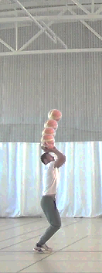 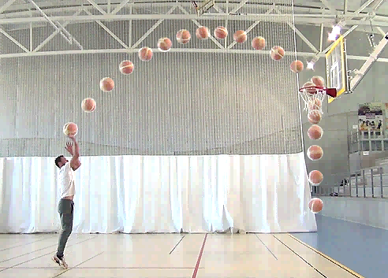

Figure 1 Figure 2

On figure 1, the ball is in contact with the basketball player’s hand.

On figure 2, the ball has left the hand of the player.

1. On document 1, label the position of the ball at times $t_{A}$, $t_{B}$, … , $t_{F}$.

*In the next question, air drag on the ball is neglected.*

1. The system is considered as the basketball: B. In the table below, place and label the forces exerted on the ball during the different phases of the throw.

|  |  |  |  |
| --- | --- | --- | --- |
| Between $t_{A}$ and $t_{B}$ | Between $t_{B}$ and $t_{C}$ | Between $t_{C}$ and $t_{D}$ | Between $t_{E}$ and $t_{F}$ |
|  |  |  |  |

### Acquiring vocabulary:

Using the previous documents, find a translation for the following expressions:

|  |  |
| --- | --- |
| **English** | **French** |
| trajectory |  |
| air drag |  |
| forces exerted on … |  |

Activity summary

What you must remember:

**- force**

**- trajectory**

Skills linked to the curriculum**:**

|  |  |
| --- | --- |
| **Fiche(s) de synthèse mobilisée(s)** | **Fiche n°5** : mouvements et interactions, rappels de 2nde |
| **Type d’activité** | * Activité « papier » |
| **Conditions de mise en œuvre** | * demi-groupe préférable mais classe entière possible * possibilité de donner à traiter à la maison |
| **Matériel utilisé** | * aucun matériel |
| **Place dans la séquence** | * début de séquence |
| **Capacités mises en œuvre dans cette activité** | **ANA**   * **Associer** une force à une action exercée par un système extérieur.   **REA**   * **Représenter** une action par le vecteur-force en respectant la direction et le sens. |