Sequence 2: Solvents and solutes

 **Fiche de synthèse mobilisée** (collection en français) :

* Fiche n°2.b: détermination de masses et de quantité de matière
* Fiche n°2.c: solvants et solutions
* Fiche n°2.d: concentration et solubilité

 **Sommaire des activités ETLV**:

* ACTIVITY 1: Dissolving solids in water
* ACTIVITY 2: Chemistry and cooking: about dissolution

ACTIVITY 1: Dissolving solids in water

**DOCUMENT 1: Molecular weights**

M (Cu) = 63.5 g.mol-1

M (S) = 32 g.mol-1

M (O) = 16 g.mol-1

M (H) = 1.0 g.mol-1

* Dissolving sugar in water

Experimental procedure:

- Place 50 mL of water in a beaker.

- Weigh the mass of the beaker and the water.

- Add 10 g of sugar.



The mass of the beaker filled with water was 150 g.

10 g of sugar was weighed out.

.

The sugar added to the water sank to the bottom.

1. Fill in the empty box to show what you think the mass of the beaker and its contents would be when the sugar was first added.
2. Five minutes later the sugar could no longer be seen: what do you think the mass of the beaker and its contents would be?
3. Explain what happens and write the chemical equation for sugar dissolving in water.

* Dissolving salt (NaCl) in water

Experimental procedure:

- Place 100 mL of water in a beaker.

- Weigh the mass of the beaker and the water.

- Add 10 g of salt.



The mass of the beaker filled with water was 150 g.

10 g of salt was weighed out.

.

The salt added to the water sank to the bottom.

1. Fill in the empty box to show what you think the mass of the beaker and its contents would be when the salt was first added.
2. Five minutes later the salt could no longer be seen: what do you think the mass of the beaker and its contents would be?
3. Explain what happens and write the chemical equation for salt (NaCl) dissolving in water.

* Dissolving sulfate copper in water

1. Label the types of glassware below: graduated cylinder, scale, distilled water, beaker, volumetric flask, funnel, Erlenmeyer flask, volumetric pipette, spatula

 File:GraduatedCylinder.svg 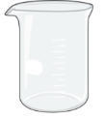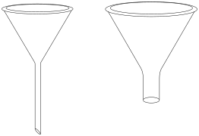 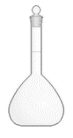 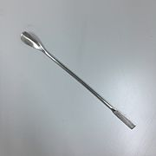 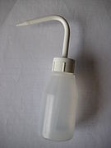

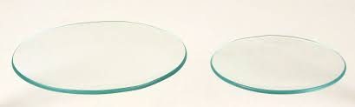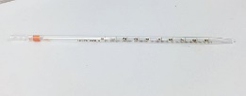 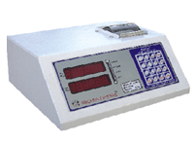

**Source: wikimediacommons**

1. What type of glassware would be suitable for preparing 100 mL of a 0.2 mol. L-1 solution of copper sulfate?
2. Using **document 1**, calculate the molecular weight of copper sulfate pentahydrate (CuSO4,5H2O).
3. Calculate the needed mass of copper (II) sulfate pentahydrate (CuSO4,5H2O) to prepare this solution.
4. Write an experimental procedure to do so.
5. Write the chemical equation for copper sulfate pentahydrate dissolving in water
6. Why did the water turn blue?

ACTIVITY 2: Chemistry and cooking: about dissolution!

To make what is termed a pound pudding, take of raisins, currants thoroughly washed, one pound each; chop a pound of suet very finely and mix with them; add a quarter of a pound of flour, or bread very finely crumbled, three ounces of sugar, one ounce and a half of grated lemon-peel, half a small nutmeg, one teaspoonful of ginger, half a dozen eggs well beaten; work it well together, put it into a cloth, tie it firmly, allowing room to swell, and boil not less than five hours. It should not be suffered to stop boiling. [FROM GODEY'S LADY'S BOOK, DEC. 1860]

**DOCUMENT 2: English Christmas pudding**

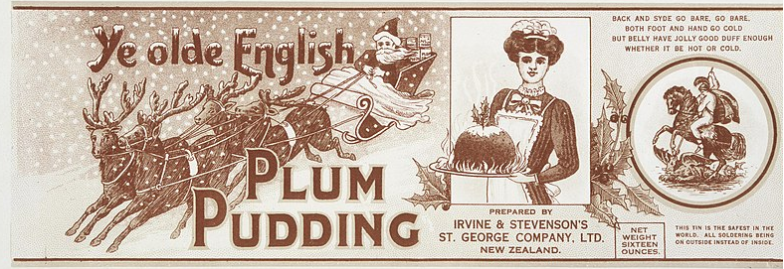

Source: Wikimediacommons

**DOCUMENT 3: Metric system versus “English system”**

The great majority of the countries uses the Metric System. All the scientists across the world use the Metric System allowing to accurately compare their findings. The USA remains one of the countries that has not adopted the metric system as its official system of measurement. The Metric System (since 1960) is now correctly called "International System of Units".

|  |  |  |
| --- | --- | --- |
| Dimension (symbol) | « English » units | Metric equivalent |
| Length (l) | Mile (mi), foot (ft), Inch (in) | 1 mi = 1,6 km  1 in = 2,54 cm  1 ft = 30,48 cm |
| Mass (m) | Pound (lb), Ounce (Oz) | 2,205 lb = 1 kg  1 Oz = 28,35 g |
| Volume (V) | Fluid ounce (fl oz),  Cup, Teaspoon (tsp),  Tablespoon (Tbsp) | 1 fl oz » 30 mL  1 cup » 240 mL  1 tsp » 5 mL  1 Tbsp  15 mL |

1. Match these words with their picture or their definition

|  |  |
| --- | --- |
| to swell | a set of instruction you need follow for an experiment |
| grated | as much as a spoon can hold |
| procedure | to become larger than normal |
| to chop | a [type](https://dictionary.cambridge.org/us/dictionary/english/type) of  [fat](https://dictionary.cambridge.org/us/dictionary/english/fat) used in [cooking](https://dictionary.cambridge.org/us/dictionary/english/cooking), |
| suet | illustrations, cliparts, dessins animés et icônes de râpe à légumes - grated |
| spoonful | hacher 2 - to chop photos et images de collection |

1. Highlight all the units used in the “English Christmas Pudding” recipe.
2. Convert all the units in the metric system using **document 3.**
3. Explain why the “English Christmas Pudding” tastes sweet when sugar is added to the recipe.

Activity summary

What you must remember:

* **conservation of mass on dissolving**
* **experimental procedure: dissolution**
* **concentration**
* **units in the metric system**

|  |  |  |  |  |
| --- | --- | --- | --- | --- |
| **to dissolve** | dissoudre |  | **glassware** | verrerie |

Skills linked to the curriculum**:**

|  |  |  |
| --- | --- | --- |
| **Compétences** | **Capacités à maîtriser** | **Où dans cette séquence ?** |
| **APP** | Utiliser du vocabulaire spécifique | Activités 1 à 2 |
| Lire et comprendre des documents scientifiques | Activités 1 à 2 |
| **ANA** | Mettre en lien des documents pour émettre des hypothèses en réponse à une question scientifique | Activités 1 à 2 |
| **COM** | S’exprimer à l’écrit en utilisant le vocabulaire adapté | Activités 1 à 2 |
| **REA** | * + modéliser par une équation de réaction la dissolution d’une espèce solide moléculaire ou ionique   + effectuer un bilan de matière lors de la dissolution totale d’une espèce ionique   + réaliser une dissolution | Activité 1 |