Sequence 8: forces and interactions

** Fiche de synthèse mobilisée** (collection en français) :

* Fiche n°8 : forces et interactions

** Sommaire des activités ETLV** :

* ACTIVITY 1: Building a capacitor

ACTIVITY 1: Building a capacitor

**Objective**: understanding all the elements that make up a capacitor

nding how DNA strands stick together

**DOCUMENT 1: The capacitor**

Capacitors range from a simple, low-voltage setup to complex high-voltage machinery. If you just want to try your hand at making a simple capacitor, the following steps will show you how.

Materials:

* a non-metallic vessel (such as a paper cup, a glass container, or a plastic bottle)
* about 10g of salt and some warm water
* aluminum foil
* a small 5V battery
* a voltmeter and jumper wires with crocodile clip ends

**Source: wikiHow**

**DOCUMENT 2: Step 1, dissolving salt in water**

Fill a non-metallic vessel (such as a paper cup, a glass container, or a plastic bottle) with warm saltwater. Use warm water to dissolve the salt.

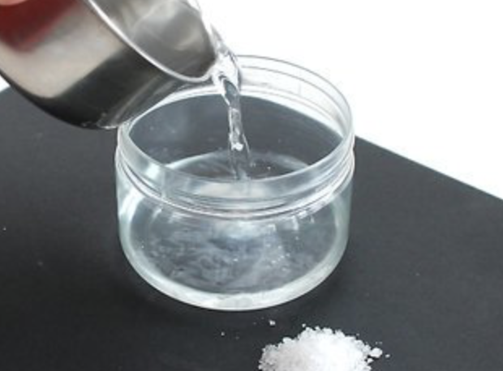

**Source: wikimediacommons**

**DOCUMENT 3: Step 2, Wrap the vessel with aluminum foil**

Wrap the outside of the container with foil.

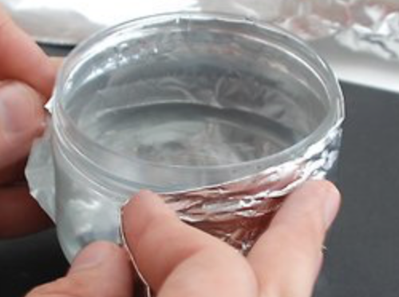

**Source: wikimediacommons**

**DOCUMENT 4: Step 3, Place a metal object in the saltwater**

Place a metal object (such as a nail, a small metal rod) in the water. The foil will play the role of an electrode, the metal object will be the other electrode. The salt water will serve as an electrolyte. Do not allow the water or the metal object to touch the foil or spill over the side. This will short the capacitor and make it impossible to charge.

**Source: wikimediacommons**

**DOCUMENT 5: Step 4, Charge up the capacitor**

Charge it up, by applying the voltage from an ordinary household battery, to both electrodes.

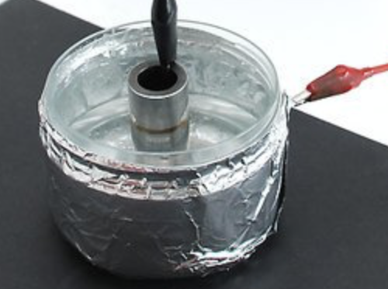

**Source: wikimediacommons**

**DOCUMENT 6: Step 5, Measure the voltage**

After a few seconds disconnect the battery and connect the voltmeter to the electrodes of the capacitor. Any reading (mV-V) will indicate a charge.

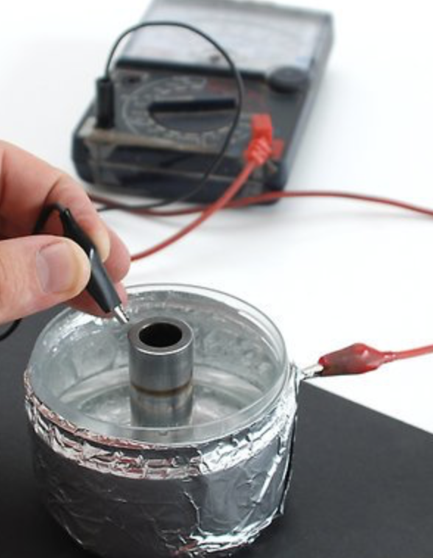

**Source: wikimediacommons**

### Understanding:

Put the five steps in order:

|  |  |
| --- | --- |
| **Description of the step** | **Number** |
| Measure the voltage |  |
| Place a metal object |  |
| Dissolve salt in water |  |
| Charge the capacitor |  |
| Wrap the vessel with aluminum foil |  |

### Acquiring vocabulary:

Using arrows, connect the words/expressions to the right definitions:

|  |  |
| --- | --- |
| **Words/expressions** | **Illustration** |
| Aluminum foil |  |
| Capacitor |  |
| A vessel, a container |  |
| Jumper wires with crocodile clip ends |  |
| A household battery |  |

**Source: wikimediacommons**

### Summing up:

On the standard representation of a capacitor, add the following labels:

* the electrodes

_________________

* the electrolyte
* wires
* **+**

_________________



_________________

**Source: wikimediacommons**

### Reinvesting, going further:

How would you place the electric field E on an enlarged version of the previous representation?

_________________________________________________________________________________________________

Activity summary

What you must remember:

**- capacitor**

**- voltmeter**

**- voltage**

**- jumper wires**

**- electrodes**

Skills linked to the curriculum**:**

|  |  |  |
| --- | --- | --- |
| **Compétences** | **Capacités à maîtriser** | **Où dans cette séquence ?** |
| **APP** | * Utiliser du vocabulaire spécifique | Activité 1 |
| * Lire et comprendre des documents scientifiques | Activité 1 |
| **REA** | * Caractériser le champ électrostatique entre deux armatures planes. * Capacités expérimentales :   - Réaliser un circuit électrique  - Mesurer une tension électrique … dans un circuit. | Activité 1 |