Sequence 13: telescopes

** Fiches de synthèse mobilisée** (collection en français) :

* Fiche n°13a : formation des images par un miroir
* Fiche n°13b : le télescope de Newton

** Sommaire des activités ETLV** :

* ACTIVITY 1: Planck’s telescope
* ACTIVITY 2: Webb’s telescope
* hat happens when we see a beach ball?ACTIVITY 2: brain diagram

ACTIVITY 1: Planck’s telescope

**Objective**: to learn about telescopes

**DOCUMENT 1: Planck’s mission**

*Planck was Europe's first mission to study the* ***Cosmic Microwave Background****, the relic radiation from the Big Bang, which occurred about 14 thousand million years ago.*

As the early universe expanded, it cooled, and at a time called 'recombination', it had cooled sufficiently for electrons and nuclei to form atoms. At this time the light that had been bouncing about within the plasma became free to travel through space (as if the universe had switched from being opaque to transparent). This freed light was initially energetic, but with the continued expansion of the universe, what was once a searing fireball of radiation has since cooled to become a background sea of **microwaves**.

**Source: ESA**

**DOCUMENT 2: Planck’s telescope**

*Planck's large telescope collected the light from the Cosmic Microwave Background and focused it onto the* ***focal******plane*** *of the scientific instruments on board.*

The **primary mirror**, 1.9 x 1.5 m in diameter, weighed only about 28 kg; the effective telescope **aperture** was 1.5 m. It was designed to be robust enough to withstand the 'shake-and-bake' stresses of launch, and the temperature difference between **launch**, when it was at an ambient temperature of about 300 K, and operation, at about 40 K.

It was made of carbon-fiber-reinforced plastic and coated with a thin **reflective layer** (reflectivity >99.5%) of aluminium - so smooth that any bumps in the coating are less than 5 microns in size. The telescope was surrounded by a large **baffle** that minimises stray light interference from the Earth, Sun and Moon, and cooled it by radiating heat into space.

**Source: ESA**

**DOCUMENT 3: Planck’s telescope upclose**

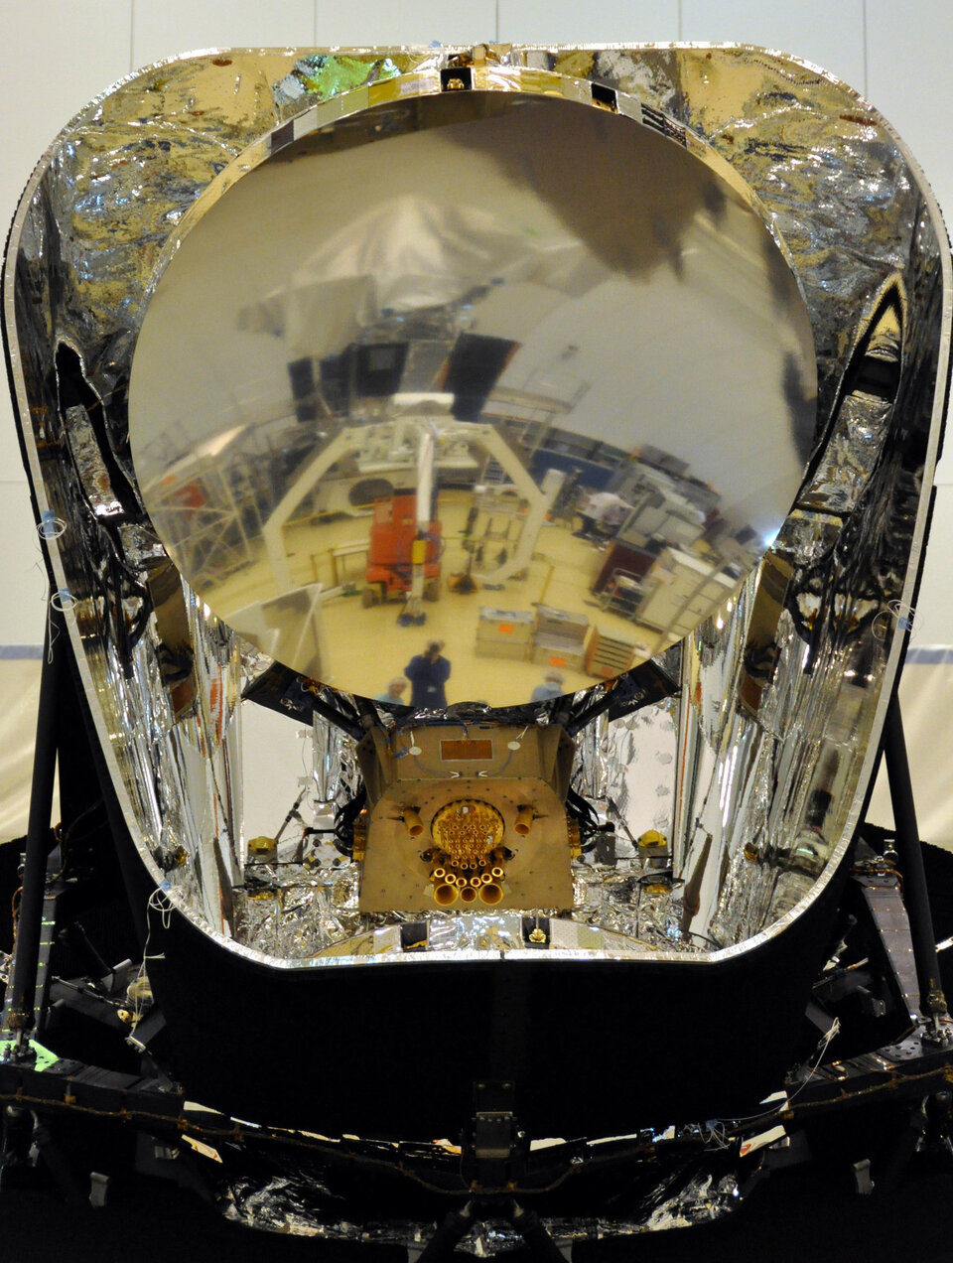

**Source: ESA**

### Acquiring vocabulary:

Using the previous documents, find a translation for the following expressions:

|  |  |
| --- | --- |
| **English** | **French** |
| Cosmic mircrowave background |  |
| focal plane |  |
| primary mirror |  |
| aperture |  |
| launch |  |
| Reflective layer |  |
| baffle |  |

### Understanding:

What was Planck’s mission?

_________________________________________________________________________________________________

_________________________________________________________________________________________________

_________________________________________________________________________________________________

Which main component of the telescope is described in the documents?

_________________________________________________________________________________________________

_________________________________________________________________________________________________

_________________________________________________________________________________________________

ACTIVITY 2: Webb’s telescope

**Objective**: to learn about future telescopes

**DOCUMENT 4: Webb’s telescope**

*The launch of the NASA/ESA/CSA James Webb Space Telescope (Webb) on an Ariane 5 rocket from Europe’s Spaceport in French Guiana is now planned for 31 October 2021.*

NASA has announced the decision, based on a recently completed schedule risk assessment of the remaining integration and test activities before launch, accounting for impacts from the COVID-19 pandemic and technical challenges. Previously, Webb was targeted to launch in March 2021.

The observatory will detect light from the first generation of stars and galaxies that formed in the early Universe and will study the atmospheres of habitable exoplanets.

Next year, Webb will be still folded in its launch configuration for shipment to the launch site and fitted inside the Ariane 5 launcher fairing (about 5 m wide). On its journey into space, Webb will be the first mission to complete an intricate and technically challenging series of deployments — a critical part of Webb’s journey to its orbit about one and a half million kilometres from Earth. Webb will unfold its delicate five-layered sunshield until it reaches the size of a tennis court. It will then deploy its 6.5 m primary mirror that will detect the faint light of distant stars and galaxies.

**Source: ESA**

**DOCUMENT 4: Webb’s telescope**

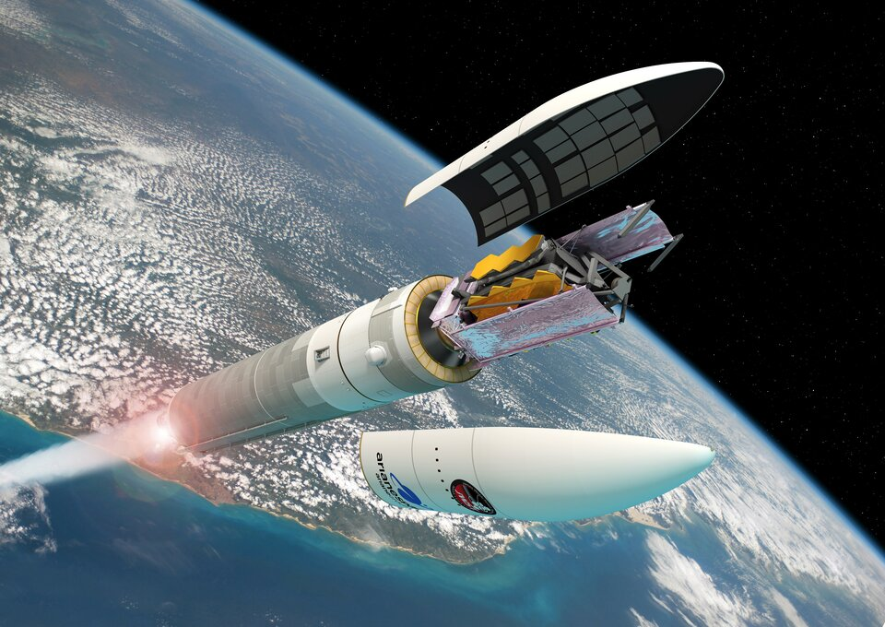

**Source: ESA**

### Understanding:

What is Webb’s new mission?

_________________________________________________________________________________________________

_________________________________________________________________________________________________

_________________________________________________________________________________________________

How does Webb’s primary mirror compare to Planck’s mirror?

_________________________________________________________________________________________________

_________________________________________________________________________________________________

_________________________________________________________________________________________________

Activity summary

What you must remember:

**- telescope**

Skills linked to the curriculum**:**

|  |  |  |
| --- | --- | --- |
| **Compétences** | **Capacités à maîtriser** | **Où dans cette séquence ?** |
| **APP** | Utiliser du vocabulaire spécifique | Activités 1 à 2 |
| Lire et comprendre des documents scientifiques | Activités 1 à 2 |
| **ANA** | Mettre en lien des documents pour émettre des hypothèses en réponse à une question scientifique | Activité 1 |
| **COM** | S’exprimer à l’écrit en utilisant le vocabulaire adapté | Activité 1 |