Sequence 7: storing and transmitting images

** Fiches de synthèse mobilisée** (collection en français) :

* Fiche n°7 : numérisation et transfert d’images

** Sommaire des activités ETLV** :

* ACTIVITY 1: how much time to download a picture?

ACTIVITY 1: how much time to download a picture?

**DOCUMENT 1: pixel (PICture ELement)**

A pixel as the smallest element of an image. A pixel can store a value proportional to the light intensity at that particular location.

**DOCUMENT 2: Pixel resolution**

Pixel resolution refers to the total number of pixels in a digital image. For example, if an image has M rows and N columns, then its resolution can be defined as M X N.

If we define resolution as the total number of pixels, then pixel resolution can be defined with set of two numbers. The first number the width of the picture, or the pixels across columns, and the second number is height of the picture, or the pixels across its width.

We can say that the higher is the pixel resolution, the higher is the quality of the image.

**DOCUMENT 3: image size**

The size of an image can be defined by its pixel resolution. Size = pixel resolution X bpp (bits per pixel).

**DOCUMENT 4: Saturn**

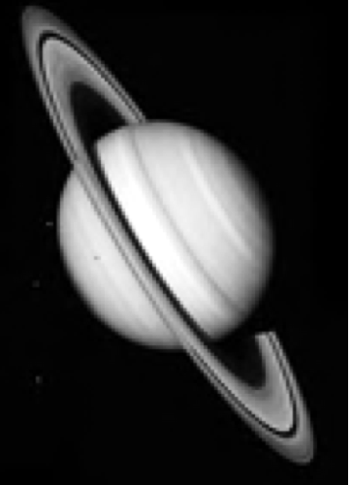 This picture contains 131 rows and 142 columns of pixels: 131x142 pixels. It was stored using 8 bits per pixel.

### Vocabulary:

Try to find the meaning of the following words/expressions:

|  |  |
| --- | --- |
| **English** | **French** |
| row |  |
| column |  |
| width |  |
| height |  |
| size |  |
| to store |  |
| to download a picture |  |

### Solving a problem:

What is the pixel resolution of the picture of Saturn?

___________________________________________________________________________________________________________________________________________________________________________________________________________________________________________________________________________________________________

What is the storage memory used up for the picture of Saturn?

___________________________________________________________________________________________________________________________________________________________________________________________________________________________________________________________________________________________________

How much time would you need to download this picture using a fiber-optic internet connection which allows download at 12.5 Mbytes per second?

___________________________________________________________________________________________________________________________________________________________________________________________________________________________________________________________________________________________________

Connaissances et capacités à maîtriser

Ce qu’il faut savoir faire :

|  |  |  |
| --- | --- | --- |
| **Compétences** | **Capacités à maîtriser** | **Où dans cette séquence ?** |
| **APP** | Utiliser du vocabulaire spécifique | Activité 1 |
| Lire et comprendre des documents scientifiques | Activité 1 |
| **ANA** | Mettre en lien des documents pour émettre des hypothèses en réponse à une question scientifique | Activité 1 |
| **COM** | S’exprimer à l’écrit en utilisant le vocabulaire adapté | Activité 1 |